|  |
| --- |
| **A Project Report on**  **AGRICULTURAL LOAN MONITORING TOOL**  By  **S. Pujitha (14251A0548)**  **V. Harshitha (14251A0558)**  **P. Sanjitha Reddy (14251A0598)**  **Department of Computer Science & Engineering**  **G. Narayanamma Institute of Technology & Science**  **(For Women)**  Approved by AICTE, New Delhi & Affiliated to JNTUH, Hyderabad  Accredited by NBA & NAAC, An ISO 9001:2015 Certified Institution  Shaikpet, Hyderabad 500 104  April, 2018  **A Project Report on**  **Agricultural Loan Monitoring Tool**  **Submitted to the Department of Computer Science & Engineering, GNITS in the partial fulfillment of the academic requirement for the award of B.Tech (CSE) under JNTU**  By  **S. Pujitha (14251A0548)**  **V. Harshitha (14251A0558)**  **P. Sanjitha Reddy (14251A0598)**  under the guidance of  **Dr. K. Venugopal Rao**  **Professor**  **Department of Computer Science & Engineering**  **G. Narayanamma Institute of Technology & Science**  **(for Women)**  Approved by AICTE, New Delhi & Affiliated to JNTUH, Hyderabad  Accredited by NBA & NAAC, An ISO 9001:2015 Certified Institution  Shaikpet, Hyderabad – 500 104  April, 2018  **G. Narayanamma Institute of Technology & Science**  **(For Women)**  Approved by AICTE, New Delhi & Affiliated to JNTUH, Hyderabad  Accredited by NBA & NAAC, An ISO 9001:2015 Certified Institution  **Shaikpet, Hyderabad – 500 104**  Department of Computer Science & Engineering Certificate This is to certify that the Project report on “**Agricultural Loan Monitoring Tool**” is a bonafide work carried out by **S.Pujitha (14251A0548), V.Harshitha (14251A0558), P.Sanjitha Reddy (14251A0598)** in the partial fulfillment for the award of B.Tech degree in Computer Science & Engineering, G. Narayanamma Institute of Technology & Science, Shaikpet, Hyderabad, affiliated to Jawaharlal Nehru Technological University, Hyderabad under our guidance and supervision.  The results embodied in the project work have not been submitted to any other University or Institute for the award of any degree or diploma.  **Internal Guide Head of the Department**  **Dr. K. Venugopal Rao Dr. M. Seetha**  **Professor Professor and HOD,**  **Department of CSE**    **External Examiner**  **Acknowledgements**  We would like to express our sincere thanks to **Dr K Ramesh Reddy**, **Principal** GNITS, for providing the working facilities in the college.  Our sincere thanks and gratitude to **Dr. M Seetha, Head and Professor**, Dept. of CSE, GNITS for all the timely support and valuable suggestions during the period of our project.  We are extremely thankful to **Dr. K. Venugopal Rao, Professor, Dr N Kalyani , Professor, Dr D V Lalitha Parameswari, Sr Asst Professor, Mrs D Manju, Asst Professor and Mr B Vamshi, Asst Prof,** Dept. of CSE, GNITS, project coordinators for their encouragement and support throughout the project  We are extremely thankful and indebted to our internal guide, **Dr. K. Venugopal Rao, Professor, Department of CSE,** GNITSfor his constant guidance, encouragement and moral support throughout the project.  Finally, we would also like to thank all the faculty and staff of CSE Department who helped us directly or indirectly, parents and friends for their cooperation in completing the project work.  **S. Pujitha (14251A0548)**  **V. Harshitha (14251A0558)**  **P. Sanjitha Reddy (14251A0598)**    **ABSTRACT**  Agricultural loan lenders in today’s environment face many challenges when evaluating the credit worthiness of farm borrowers. The success or failure of any financial institution is closely tied to the quality of its loan portfolio and its loan monitoring system. In agricultural lending, there are some risks, careful monitoring to avoid these risks is crucial. A monitoring system provides the information needed to oversee loan portfolio quality at any given time, identifying potential problems at the earliest moment possible.  This project helps to monitor climatic conditions for agricultural land and generate the relevant reports. These reports can be used by Banks to Assess, Waive or Grant new Agricultural Loans and by the farmers for better agriculture output. Installation of Digital Humidity and Temperature, Soil moisture Sensors will calculate the real time Temperature, Humidity and soil moisture indefinitely and send the data to a cloud platform named ThingSpeak every minute and the reports would be generated based on this data dynamically. This real time sensing data and the loan history of the loan borrower are taken on which analysis is performed and generates the suggestion accordingly. This will enable the banks to consider loan waivers and the farmers for investment strategies. The same reports can be used to know if the customer is making proper use of the loan and provide constructive feedback. |

|  |
| --- |
|  |

Table of Contents

ABSTRACT…………………………………………………………………………..iv

1.INTRODUCTION 1

1.1. Objective 4

1.1.1 General objectives 4

1.1.2 Specific Objectives 4

1.2.Methodology 5

1.3. Organisation of the Document 6

2. LITERATURE SURVEY 7

2.1 Existing System 7

2.2 Disadvantages of the Existing System: 7

2.3 Proposed Model 9

3. DESIGN OF LOAN MONITORING TOOL 10

3.1 Design 10

3.2. Module Description 12

3.2.1. Sending the Data from Arduino to Thingspeak 12

3.2.2. Web Application Module 21

4. TECHNOLOGY STACK AND WORKFLOW 26

4.1 Technologies used 26

4.2.1 State chart Diagram 31

4.2.2 Use Case Diagram 32

4.2.3. Sequence Diagram 34

5. RESULTS 36

6. CONCLUSIONS AND SCOPE FOR FUTURE ENHANCEMENTS 47

6.1. Conclusions 47

6.2. Future Enhancements 47

REFERENCES 48

GLOSSARY 51

APPENDIX 54

**LIST OF FIGURES**

|  |  |  |  |
| --- | --- | --- | --- |
| SNo | Figure No | Figure Name | Page No |
| 1 | Fig.1.1 | Architecture of the agricultural loan monitoring tool | 5 |
| 2 | Fig 3.1 | Block diagram for Sending sensor data to cloud | 10 |
| 3 | Fig 3.2 | Block diagram for farmers view | 10 |
| 4 | Fig 3.3 | Block Diagram for bankers view | 11 |
| 5 | Fig 3.4 | Block diagram for checking the trustworthiness of farmer | 11 |
| 6 | Fig 3.5 | Arduino Uno Board | 13 |
| 7 | Fig 3.6 | Pin Description of Arduino | 13 |
| 8 | Fig 3.7 | DHT11interfacing with Arduino | 14 |
| 9 | Fig 3.8 | Pin Out – Diagram | 15 |
| 10 | Fig 3.9 | Circuit Diagram – Analog Mode | 16 |
| 11 | Fig 3.10 | ESP8266 Module | 17 |
| 12 | Fig 3.11 | Serial Monitor output | 18 |
| 13 | Fig 3.12 | Setup of hardware components | 19 |
| 14 | Fig 3.13 | Visualization of sensor data in thingspeak | 21 |
| 15 | Fig 3.14 | Flow diagram for approve/reject loan | 23 |
| 16 | Fig 3.15 | Flow diagram for repayment of loan | 24 |
| 17 | Fig 4.1 | Parts of Arduino IDE | 26 |
| 18 | Fig 4.2 | ThingSpeak channel showing write and read api keys | 28 |
| 19 | Fig 4.3 | State Diagram for flow of the project | 31 |
| 20 | Fig 4.4 | Usecase diagram for User | 32 |
| 21 | Fig 4.5 | Usecase diagram of Web Application for Farmer | 32 |
| 22 | Fig 4.6 | Usecase diagram of Web Application for Bank Admin | 33 |
| 23 | Fig 4.7 | Usecase diagram of farmer’s view | 33 |
| 24 | Fig 4.8 | Usecase diagram of banker’s view | 34 |
| 25 | Fig 4.9 | Sequence diagram of Web Application | 35 |
| 26 | Fig 5.1 | Serial Monitor Output | 36 |
| 27 | Fig 5.2 | Thingspeak Output | 36 |
| 28 | Fig 5.3 | Home Page of Web Application | 37 |
| 29 | Fig 5.4 | About Us Page | 37 |
| 30 | Fig 5.5 | Services Page | 38 |
| 31 | Fig 5.6 | Contact Us Page | 38 |
| 32 | Fig 5.7 | Farmers Login Page | 39 |
| 33 | Fig 5.8 | Farmer’s Sign up page | 39 |
| 34 | Fig 5.9 | My Account Page of Farmer | 40 |
| 35 | Fig 5.10 | Bank Admin Login Page | 40 |
| 36 | Fig 5.11 | Bank Admin Account Page with all the loan | 41 |
| 37 | Fig 5.12 | Bank Admin Account Page with all the loan applications of particular farmer | 41 |
| 38 | Fig 5.13 | Suggestion about loan approval | 42 |
| 39 | Fig 5.14 | Suggestion about new loan approval | 42 |
| 40 | Fig 5.15 | Suggestion about loan approval in installments | 43 |
| 41 | Fig 5.16 | Repayment Page | 43 |
| 42 | Fig 5.17 | Farm condition of a particular farmer | 44 |
| 43 | Fig 5.18 | Closing of the loan application | 44 |
| 44 | Fig 5.19 | Database details | 45 |
| 45 | Fig 5.20 | Farmer Account details | 45 |
| 46 | Fig 5.21 | Bank Admin Credentials | 46 |
| 47 | Fig 5.22 | Farmer Loan details | 46 |

# 1.INTRODUCTION

The Internet of Things (IoT) has the capability to [transform the world](https://www.iotforall.com/internet-of-things-examples-applications/) we live in; more-efficient industries, connected cars, and smarter cities are all components of the IoT equation. The IoT is a highly promising family of technologies which is capable of offering many solutions towards the modernisation of agriculture. Scientific groups and research institutions, as well as the industry, are in a race trying to deliver more and more IoT products to the agricultural business stakeholders, and, eventually, lay the foundations to have a clear role when IoT becomes a mainstream technology. At the same time Cloud Computing, which is already very popular, and Fog Computing provide sufficient resources and solutions to sustain, store and analyse the huge amounts of data generated by IoT devices. The management and analysis of IoT data (“Big Data”) can be used to automate processes, predict situations and improve many activities, even in real-time.

Moreover, the concept of interoperability among heterogeneous devices inspired the creation of the appropriate tools, with which new applications and services can be created and give an added value to the data flows produced at the edge of the network. The agricultural sector was highly affected by Wireless Sensor Network (WSN) technologies and is expected to be equally benefited by the IoT. However, the application of technology like IoT in agriculture could have the greatest impact. The global population is set to touch [9.6 billion by 2050](http://www.computerweekly.com/news/2240239484/IoT-could-be-key-to-farming-says-Beecham-Research). So, to feed this much population, the farming industry must embrace IoT. Against the challenges such as extreme weather conditions and rising climate change, and environmental impact resulting from intensive farming practices, the demand for more food has to be met.

Smart farming based on IoT technologies will enable growers and farmers to reduce waste and enhance productivity ranging from the quantity of fertilizer utilized to the number of journeys the farm vehicles have made. In this a system is built for monitoring the crop field with the help of sensors (light, humidity, temperature, soil moisture, etc.) and automating the irrigation system. In terms of environmental issues, IoT-based smart farming can provide great benefits including more efficient water usage, or optimization of inputs and treatments. The soil moisture probe technology provides complete in-season local agronomy support, and recommendations to optimize water use efficiency. Soil sensors can alert farmers to irregular conditions like high acidity, giving the farmer time to reconcile the issue and produce better crops. DHT11 sensor is used to measure the [**temperature**](http://microcontrollerslab.com/temperature-sensor-using-pic16f877a-microcontroller/) and [**humidity**](http://microcontrollerslab.com/digital-humidity-sensor-using-pic-microcontroller/) of the crop, helps in better analysis and give better suggestion.

IoT agricultural applications are making it possible for loan lenders and farmers to collect meaningful data. Loan lenders must understand the potential of IoT market for agriculture in order to better understand the farm conditions during repayment process.

Agricultural lenders are facing many challenges when evaluating the credit worthiness of loan borrowers. Financial Institutions has to monitor its loan system to mitigate risks. When a farmer comes and asks for the loan the bank should be able to grant loan only to loyal customers and reject for others. Even during the repayment of loan, the bank should be able to know whether the farmer is genuine or not. In order to overcome all these problems we develop a tool that provides the information needed to oversee loan portfolio at any time, identifying potential problems.

The loan process is considered complicated and time consuming. The farmers require crop loans during the particular seasons. If they do not get the credit in time, it will not serve the desired purpose. The delay in processing the loan is a common problem felt by the farmers. Similarly, if the farmers require term loan for buying certain assets, it is also required in time. Otherwise, if the asset is bought after the work has been done, the asset will remain idle till its next use. The farmers also complain about the complications in the loan process. These complications may relate to the procedural complications and behavioural complications.

It is said that getting a loan is difficult but its repayment in time is more difficult. They are expected to repay the loan immediately after the harvest. Sometimes, they do not get fair price after harvest. But due to hard conditions of repayment, they have to sell the crop without any bargain regarding price. It creates a problem in their minds whether to go for such loans or not.

The problem of mounting over dues has become a major cause of concern for the banking institutions. The amount of recoverable loans from the farming sector has been piling up day by day. The interaction of the researcher with branch managers regarding this major issue revealed the following causes for poor recovery of loans:

1. The farming activities are largely dependent on the mercy of Almighty God in our country. Nature plays havoc with the farmers almost every year. Natural calamities like floods or droughts ruin the crops of the farmers and they are left with very little produce. It affects their repaying capacity and as a result, the recovery of loans becomes a tough task.

2. It is very common among the farmers that they use the amount of loan for domestic or leisure purposes. Sometimes, they spend the loan money on social functions, litigation, sickness and other such purposes. It leads to reduction in the revenue and ultimately affects their capacity to repay the loan.

3. Banks are not able to check the proper utilization of loan by the farmer. The farmers are illiterate and ignorant about the financial management practices. They do not know how to make the optimum use of the loan taken. They simply take the loan as their own money and many times use it on wasteful items. They also do not maintain any account of the loan taken by them. Basically, they do not understand the cost of the loaned capital. It results in non-recovery of loans.

4. The main and greatest problem of the banking sector is repayment of loan. Most of the people have developed an attitude of willful default because they feel that the loan taken by them is the money of the government and it is not meant to be repaid. There have been situations when because of political considerations, the respective governments waived off the loans of the farmers. As a result, people have developed the feeling that the governments will again waive off the loans and they simply go on waiting for that time.

5. Due to failure of crops the banks pressure from cultivators to convert crop loans in to term loans the banks operating in a particular area cannot be decided on their own.

To overcome the problems faced by both the banks and the farmer this tool helps in bridging the gap between the agricultural loan lenders and the farmers without any interference of the middle man. This tool helps in finding the trustworthiness of the farmer and helps bank to make correct decisions based on the real time data collected from the sensors.

This tool also helps during repayment of the loan and helps banks to rate the trustworthiness of that farmer and based on that they can waive the loan and the same feedback can be used for the rest loan applications to grant or waive the loan.

## 

## 1.1. Objective

Agricultural Loan Monitoring Tool allows us to monitor climatic conditions for agricultural land and generate the relevant reports. These reports can be used by Bank to Assess, Waive or Grant new Agricultural loans and by farmers for better agricultural output.

The same reports can be used to know if the customer is making proper use of the loan and provide constructive feedback.

### **1.1.1 General objectives**

The general objective of our project is many loaning organizations and farmers can use this tool for better judgement and improve the crop outcome.

### **1.1.2 Specific Objectives**

Included in the general objective, our project is also expected to fulfill or achieve the

following specific objectives:

* ALMT Web App (Gets data from the sensors and shows reports)
* Micro-controller (Arduino (Hardware +Software)) and it’s integration with Web App
* Integration of Bluetooth/Wi-Fi module with Sensors and Micro-Controller
* Collecting and sending real time sensor data to the cloud.
* To provide an easy and secure way to provide the loan.
* The Agricultural Loan Monitoring Tool allows banks to test the trustworthiness of the farmers.

## 

## 1.2.Methodology

Cloud

Arduino

Web

Application

Database

Fig.1.1 Architecture of the agricultural loan monitoring tool

Installing of Soil Moisture, Digital Humidity and Temperature Sensors will calculate the real time Soil moisture, temperature and humidity indefinitely and send the data to a cloud environment (thingspeak) every minute and reports would be generated based on this data and the farmer’s loan history is stored in the database.

Suggestions were given to the loan lenders to grant or waive the loan based on the analysis. This will enable the banks to consider loan waivers and the farmers for investment strategies. The same reports can be used to know if the customer is making proper use of the loan and provide constructive feedback.

A Web application is developed which is used by both farmers and bankers simultaneously. It allows farmers to make a loan request and by the bank admin to grant or waive the loan based on the loan history and crop history and bank admin can either close the application based on the analysis provided.

This tool can also be used during the repayment of the loan, if a farmer says that he/she cannot repay the loan due to natural calamities then the bank admin can cross check the farm condition of particular farmer which is analysed by the sensors data as we are monitoring the field of the farmer after giving the loan.

## 

## 1.3. Organisation of the Document

The project has been divided into two modules, dividing the software and hardware components.

**Module 1:**

The software module includes the web application developed using

* This application’s user interface is designed such a way that both farmer and the bank admin can access it simultaneously.
* The user can create a new account and then login using his aadhaar number and password. Once he logs in he will be redirected to a page where he can request for a new loan.
* The bank admin may login using his credentials then he will be redirected to page where he can get all the requests made by different farmers appear.
* Bank admin can either grant or waive the loan based on the suggestion provided.
* Banker is also provided with repayment option where he/she can search for that particular farmer and check if can produce the revenue or not based on the crop analysis and his loan history.
* Banker is also given an option to close the application of the farmer.

**Module 2:**

* The hardware module includes the usage of Arduino microprocessor, soil moisture, DHT11 and ESP8266 in order to achieve crop monitoring and providing the suggestion to the banker.
* DHT11 sensor detects the temperature and the humidity of the crop, where as soil moisture sensor gives the moisture content of the soil in analog values.
* All the values detected by the sensors are send to the Things speak cloud using a wifi module (ESP8266) every minute to minute.
* ThingSpeak is an IoT analytics platform service that allows you to aggregate, visualize and analyze live data streams in the cloud. ThingSpeak provides instant visualizations of data posted by your devices to ThingSpeak.
* On the collected data using different sensors and the loan history which is presented in the database an algorithm is applied based on which suggestion is given to banker to approve or reject the loan.

# 2. LITERATURE SURVEY

## 2.1 Existing System

Agricultural loan is considered an important input for modern agriculture. Credit is temporary transfer of purchasing power. It is the external source of capital for investment. Loan often necessary is only one instrument for promoting agricultural development.

In present day system the farmer has to go to nearby bank and submit the necessary documents for granting the loan. But as this a manual process it takes a longer time for generating the required loan to the farmer.

## 2.2 Disadvantages of the Existing System:

Problems faced by farmer:

* The primary need of the farmer is timely supply of the credit. The cumbersome procedure of disbursement of loans, high time taken in releasing the subsidies and other procedural formalities sometimes defeat the very purpose of the loan. As a result, the loan obtained after the desired time is used for some other purpose.
* Farmers have to face the number of problems, one of them begin great difficulty in getting credit.
* Climatic conditions play an important role in Indian agriculture as the agriculture of India is dependent on the variations of the monsoon.
* The interference of the middle main in getting the loan.
* Some banks are giving preferences to big farmers so small and marginal farmers are not able to get the amount they required.
* The continuous and constant natural calamities, the agricultural production is very low. So, the repayment capacity of the farmers is very less.
* Natural calamities are one of the main reasons which destroy the complete crop and makes farmers helpless.
* Farmers are unaware of the policies provided by the government to them for agricultural loan.

Problems faced by Banks:

* Banks are not able to check the proper utilization of loan by the farmer. The farmers are illiterate and ignorant about the financial management practices. They do not know how to make the optimum use of the loan taken. They simply take the loan as their own money and many times use it on wasteful items. They also do not maintain any account of the loan taken by them. Basically, they do not understand the cost of the loaned capital. It results in non-recovery of loans.
* The main and greatest problem of the banking sector is repayment of loan. Most of the people have developed an attitude of willful default because they feel that the loan taken by them is the money of the government and it is not meant to be repaid. There have been situations when because of political considerations, the respective governments waived off the loans of the farmers. As a result, people have developed the feeling that the governments will again waive off the loans and they simply go on waiting for that time.
* Due to failure of crops the banks pressure from cultivators to convert crop loans in to term loans the banks operating in a particular area cannot be decided on their own.
* Recovery of loans is one of the major problem. Crop failure or lesser production due to shortage of fertilizers, pesticides, good variety of seeds also compels farmers not to repay loans. Lesser production causes lesser income and lesser capacity of the farmers to meet their financial obligations.
* Due to continuous and constant natural calamities, the rate of recovery has been poor. Natural calamities like floods or droughts ruin the crops of the farmers and they are left with very little produce. It affects their repaying capacity and as a result, the recovery of loans becomes a tough task.
* Banks are not able to go to the field in sanctioning the loans or to check the proper utilization of loans.
* Low level of recovery by farmers due to various reasons like no proper usage of the loan amount given, natural calamities, illiteracy.

## 2.3 Proposed Model

This tool allows us to monitor climatic conditions for agricultural land and generate the relevant reports. These reports can be used by Banks to Assess, Waive or Grant new Agricultural Loans and by the farmers for better agriculture output.

Installation of DHT11, Soil moisture sensors in the agricultural field and collecting data from these sensors minute by minute and sending them to the IOT based cloud named thingspeak using a wifi module(ESP8266) which is connected to the arduino.

A web application is designed which can be used by the farmer and the agricultural loan lender simultaneously.

New customer can create his own account providing all his credentials and setting up a password. Later he/she can login using aadhaar number and the password where it will redirect to a interface where all the applications of that particular farmer are displayed along with a button which is used for requesting a new loan from a bank and then he logs out.

The admin of the bank is also provided with the login option where he can login with his own credentials then he will be redirected to the interface where all the requests from different customers are displayed along with approve or reject option. For every loan request a suggestion option is provided which is calculated based on the real time sensor data collected and the loan history of that particular customer. Based on the suggestion provided, bank admin can either grant or waive the loan.

When farmer comes to repay the loan bank the admin of the bank is provided with a repayment option where he can enter the aadhaar number of that particular farmer and search then all the applications of that particular famer along with a suggestion if his/her crop can generate revenue is displayed based on the crop analysis (real time sensor data) and the loan history of that particular customer are taken into account.

# 3. DESIGN OF LOAN MONITORING TOOL

## 3.1 Design

This tool allows us to monitor climatic conditions for agricultural land and generate the relevant reports. These reports can be used by Banks to Assess, Waive or Grant new Agricultural Loans and by the farmers for better agriculture output.

Installation of DHT11, Soil moisture sensors in the agricultural field and collecting data from these sensors minute by minute and sending them to the IOT based cloud named thingSpeak using a wifi module (ESP8266) which is connected to the arduino.

Installation of sensors

Collecting data from sensors

Sending data to the thing speak cloud

Fig. 3.1 Block diagram for Sending sensor data to cloud

A web application is designed which can be used by the farmer and the agricultural loan lender simultaneously.

**Customers view:**

New customer can create his own account providing all his credentials and setting up a password. Later he/she can login using aadhaar number and the password where it will redirect to a interface where all the applications of that particular farmer are displayed along with a button which is used for requesting a new loan from a bank and then he logs out.

Customer then logs out.

New application is generated

He/she will requests for a new loan

Customer then logs in (aadhaarno,password)

New customer creates his account

Fig. 3.2 Block diagram for farmers view

**Loan Lenders View:**

The admin of the bank is also provided with the login option where he can login with his own credentials then he will be redirected to the interface where all the requests from different customers are displayed along with approve or reject option. For every loan request a suggestion option is provided which is calculated based on the real time sensor data collected and the loan history of that particular customer. Based on the suggestion provided bank admin can either grant or waive the loan.

Loan history of that farmer from database

Real time sensor data from thingSpeak

Algorithm is applied on sensor data, loan history

Bank admin logs in (email, password)

All loan requests are displayed

Suggestion is provided based on algorithm

admin can grant/ waive based on suggestion

Fig. 3.3 Block Diagram for bankers view

When farmer comes to repay the loan bank the admin of the bank is provided with a repayment option where he can enter the aadhaar number of that particular farmer and search then all the applications of that particular famer along with a suggestion if his/her crop can generate revenue is displayed based on the crop analysis (real time sensor data) and the loan history of that particular customer are taken into account.

Suggestion is provided if crop can generate revenue/not

Enters aadhaar no of particular farmer

Clicks on repayment option

Admin logins using his credentials

Fig. 3.4 Block diagram for checking the trustworthiness of farmer

## 

## 3.2. Module Description

In order to design the system, the following modules are designed.

### **3.2.1. Sending the Data from Arduino to Thingspeak:**

This module includes Installation of Digital Humidity , Temperature and soil moisture sensors (either DHT11 or DHT22) will calculate the real time Temperature, Humidity and soil moisture indefinitely and send the data to a centralized server(Things speak) every minute and reports would be generated based on this data. This will enable the banks to consider loan waivers and the farmers for investment strategies.

**Arduino:**

A microcontroller is a small computer on a single integrated circuit containing a processor core, memory, and programmable input/output peripherals. The one we used is Arduino Uno.

Arduino is a single-board microcontroller designed to make the process of using electronics in multidisciplinary projects more accessible. The hardware consists of a simple open source hardware board designed around an 8-bit Atmel AVR microcontroller.

An Arduino board consists of an Atmel 8-bit AVR microcontroller with complementary components to facilitate programming and incorporation into other circuits. An important aspect of the Arduino is the standard way that connectors are exposed, allowing the CPU board to be connected to a variety of interchangeable add-on modules known as shields. The software consists of a standard programming language compiler and a boot loader that executes on the microcontroller.

Arduino microcontrollers are pre-programmed with a [boot loader](https://en.wikipedia.org/wiki/Boot_loader) that simplifies uploading of programs to the on-chip [flash memory](https://en.wikipedia.org/wiki/Flash_memory). The default boot loader of the Arduino UNO is the optiboot bootloader.Boards is loaded with program code via a serial connection to another computer. Some serial Arduino boards contain a level shifter circuit to convert between [RS-232](https://en.wikipedia.org/wiki/RS-232)logic levels and [transistor–transistor logic](https://en.wikipedia.org/wiki/Transistor%E2%80%93transistor_logic) (TTL) level signals. Current Arduino boards are programmed via [Universal Serial Bus](https://en.wikipedia.org/wiki/Universal_Serial_Bus) (USB), implemented using USB-to-serial adapter chips such as the [FTDI](https://en.wikipedia.org/wiki/FTDI) FT232.

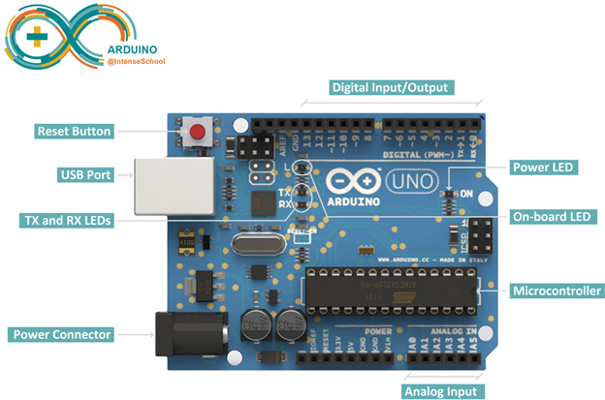

Fig. 3.5 Arduino Uno Board

Arduino Pin Description:

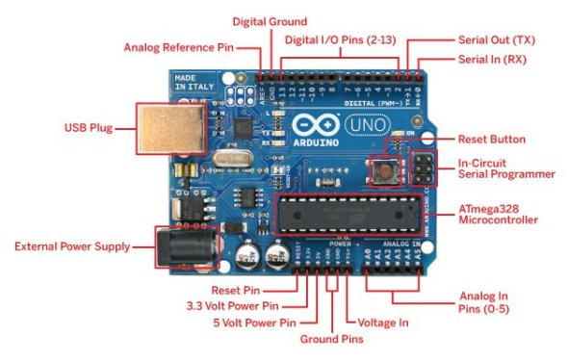

Fig. 3.6 Pin Description of Arduino

**DHT11 (Digital Humidity and Temperature Sensor):**

DHT11 sensor is used to measure the [**temperature**](http://microcontrollerslab.com/temperature-sensor-using-pic16f877a-microcontroller/) and [**humidity**](http://microcontrollerslab.com/digital-humidity-sensor-using-pic-microcontroller/). It has a resistive humidity sensing component and a negative temperature coefficient (NTC). An 8 bit MCU is also connected in it which is responsible for its fast response. It is very inexpensive but it gives values of both temperature and humidity at a time.

**Specification of DHT11**

* It has humidity range from 20 to 90% RH
* It has temperature range from 0 – 50 C
* It has signal transmission range of 20 m
* It is inexpensive
* It has fast response and it is also durable

**DHT11 Pin out**

* The first pin of the DHT11 is vcc pin.
* The second pin of the DHT is Data pin.
* The third pin is not used.
* The fourth pin of the DHT sensor is ground.

**DHT11 interfacing with arduino**

First of all connect the ground and the VCC of the DHT11 temperature and humidity sensor to the ground and 5v of the[**Arduino**](http://microcontrollerslab.com/arduino-projects/). Then connect the data pin of the DHT11 sensor to the pin 2 of the Arduino.

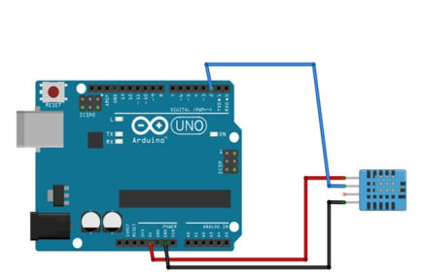

Fig. 3.7 DHT11 interfacing with Arduino

**Soil Moisture Sensor:**

This sensor measures the volumetric content of water inside the soil and gives us the moisture level as output. The sensor is equipped with both analog and digital output, so it can be used in both analog and digital mode.

**Working:**

The soil moisture sensor consists of two probes which are used to measure the volumetric content of water. The two probes allow the current to pass through the soil and then it gets the resistance value to measure the moisture value.

When there is more water, the soil will conduct more electricity which means that there will be less resistance. Therefore, the moisture level will be higher. Dry soil conducts electricity poorly, so when there will be less water, then the soil will conduct less electricity which means that there will be more resistance. Therefore, the moisture level will be lower.

This sensor can be connected in two modes: Analog mode and digital mode. First, we will connect it in Analog mode and then we will use it in Digital mode.

**Pin Out – Soil Moisture Sensor**

The soil Moisture sensor has four pins

* VCC: For power
* A0 : Analog output
* D0 : Digital output
* GND: Ground
* [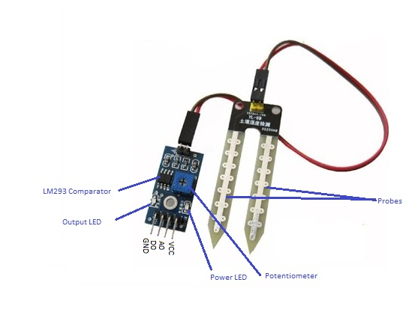](http://www.circuitstoday.com/arduino-soil-moisture-sensor/pin-out)

Fig. 3.8 Pin Out – Diagram

**Analog Mode – Interfacing Soil Moisture Sensor and Arduino**

To connect the sensor in the analog mode, we will need to use the analog output of the sensor. When taking the analog output from the soil moisture sensor , the sensor gives us the value from 0-1023. The moisture is measured in percentage, so we will map these values from 0 -100 and then we will show these values on the serial monitor.

You can further set different ranges of the moisture values and turn on or off the water pump according to it.

**Circuit Diagram**

The connections for connecting the soil moisture sensor to the Arduino are as follows.

* VCC to 5V of Arduino
* GND to GND of Arduino
* A0 to A0 of Arduino

[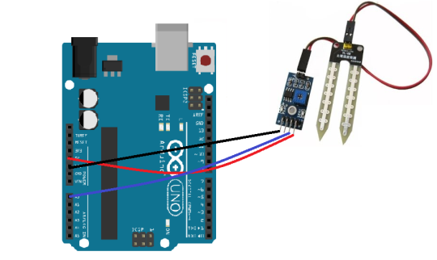](http://www.circuitstoday.com/arduino-soil-moisture-sensor/interface_soil_sensor_arduino)

Fig. 3.9 Circuit Diagram – Analog Mode

To connect the soil moisture sensor FC-28 in the digital mode, we will connect the digital output of the sensor to the digital pin of the Arduino. The Sensor module contains a potentiometer with it, which is used to set the threshold value. This threshold value is then compared with the sensor output value using the LM393 comparator which is placed on the sensor module.

**WIFI MODULE (ESP8266):**

The ESP8266 WiFi Module is a self contained SOC with integrated TCP/IP protocol stack that can give any microcontroller access to your WiFi network. The ESP8266 is capable of either hosting an application or offloading all Wi-Fi networking functions from another application processor. Each ESP8266 module comes pre-programmed with an AT command set firmware, meaning, you can simply hook this up to your Arduino device and get about as much WiFi-ability as a WiFi Shield offers. The ESP8266 module is an extremely cost effective board with a huge, and ever growing community.

This module has a powerful enough on-board processing and storage capability that allows it to be integrated with the sensors and other application specific devices through its GPIOs with minimal development up-front and minimal loading during runtime. Its high degree of on-chip integration allows for minimal external circuitry, including the front-end module, is designed to occupy minimal PCB area. The ESP8266 supports APSD for VoIP applications and Bluetooth co-existance interfaces, it contains a self-calibrated RF allowing it to work under all operating conditions, and requires no external RF parts.

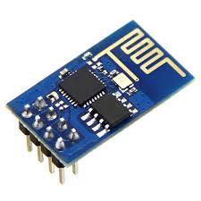

Fig. 3.10 ESP8266 Module

Commands for Connecting Wifi Module:

AT—Tests AT Startup

AT+RST—Restarts the Module

AT+RESTORE—Restores the Factory Default Settings

AT+UART—UART Configuration

AT+SLEEP—ConFig.s the Sleep Modes

AT+CWMODE—Sets the Wi-Fi Mode (Station/ SoftAP/ Station+SoftAP)

AT+CWMODE_CUR—Sets the Current Wi-Fi mode

AT+CWMODE_DEF—Sets the Default Wi-Fi mode

AT+CIPSTART—Establishes TCP Connection, UDP Transmission or SSL Connection

AT+CIPSTATUS—Gets the Connection Status

AT+CIPSEND—Sends Data

AT+CWJAP—Connects to an AP

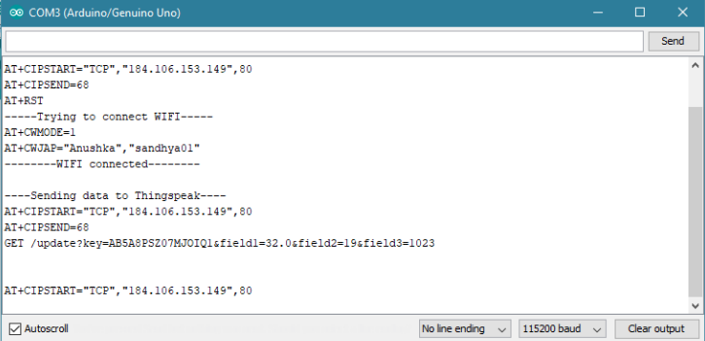

Fig. 3.11 Serial Monitor output

Baud rate in the serial monitor is set to 115200 as the communication with wifi module takes place in this baud rate.

Inorder send the data to thingspeak we use the command GET

GET /update?key= write _api key of the channel&field1=’’&field2=’’

**CIRCUIT DIAGRAM:**

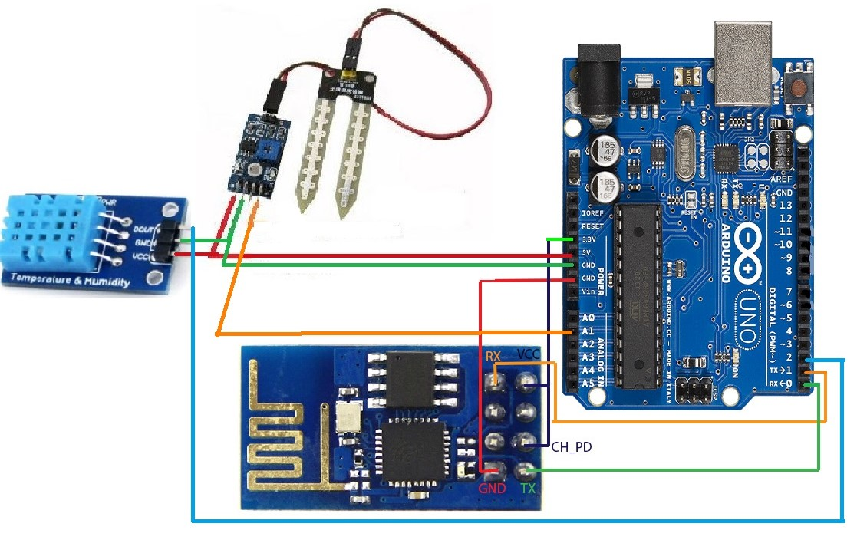

Fig. 3.12 Setup of hardware components

The following are the connections to be made:

DHT to Arduino

VCC - 5V

GND - GND

DATA - Pin 2

Soil Moisture to Arduino

GND - GND

VCC – 5V

DATA – A1

Wifi Module to Arduino

TX – RX (Pin 0)

RX – TX (Pin 1)

GND – GND

VCC, CH_PD - 3.3V

**Sending Data to ThingSpeak:**

Once the sensors are setup we have used Serial communication (also known as UART) to send data from arduino to the computer through USB serial COM ports.

This data is send to things speak cloud that allows you to aggregate, visualize and analyze live data streams in the cloud.

**Setting Up ThingSpeak Cloud:**

1. Sign Up for New User Account – <https://www.thingspeak.com/account/new>

2. Create a New Channel by selecting Channels and then Create New Channel

**Channels**

Channels are where your application stores and retrieves any type of data. Each channel has a Private View and a Public View. The Private View is only accessible by signing into your ThingSpeak.com user account. The Public View is what other viewers will see when they visit your ThingSpeak Channel. You can have different info on each view, customize the view with Plugins, and even disable the Public View.

To read and write to a ThingSpeak Channel, your application must make requests to the ThingSpeak API using HTTP requests. Each ThingSpeak Channel allows for 8 fields of data (both numeric and alphanumeric formats), location information, and a status update. Each entry is stored with a date and time stamp and is assigned a unique Entry ID (entry_id). After the data is stored, you can retrieve the data by time selection or by Entry ID. In addition to storing and retrieving numeric and alphanumeric data, the ThingSpeak API allows for numeric data processing such as time scaling, averaging, median, summing, and rounding. The channel feeds supports JSON, XML, and CSV formats for integration into applications.

**Chart API**

The Chart API allows you to create an instant visualization of your data. The chart displays properly in all modern browsers and mobile devices. The chart can also show dynamic data by loading new data automatically.

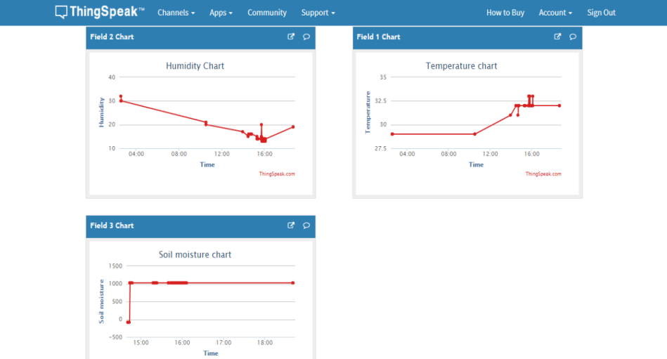

Fig. 3.13 Visualization of sensor data in thingspeak

### **3.2.2. Web Application Module**

Web application provides different services. This application consists of about us which describes about the project; services button which redirects to the page displays various services provided by the company.

1.Its consists of farmers login button where new farmer can sign up by providing all his credentials like name, aadhaar number, address, phone number ant this data is stored in the database provided.

2. Farmer then logins entering his adhaar number and password then he/she will be redirected to a page where all the loans applied by that particular farmer are displayed along with request for a new loan button. Farmer can click on this button for requesting a new loan based on his requirement.

3. Once the farmer clicks on this button a new application is generated and is added to the existing applications and the status of the application is processing. Whenever a farmer creates his/her account a new account number for that particular farmer is auto generated based on the time function. Then the farmer logs out.

4. When farmer wants to repay the loan then using his/ her aadhaar number bank admin searches for that particular farmers all the applications and a suggestion is provided if his crop an generate revenue or not.

**Bankers Login:**

1. The bank admin of the bank logins with his credentials. Once he signs in all the requests from different farmers are shown.

2. The bank admin is given an option to either reject or approve the loan based on the suggestion provided .This suggestion is based on the crop analysis that is the real time sensor data collected and stored in the cloud and the previous loan history of the farmer.

3. Based on the suggestion given the admin can either approves, reject or provide the loan in installments.

4. A repayment button is also provided where banker can enter the adhaar number of the farmer then all the applications of that particular farmer are displayed along with suggestion based on the crop analysis and loan history if the crop can generate revenue or not based on which he can close the application.

**Algorithm**:

Data from different sensors placed in the agricultural land are used to collect temperature, humidity and soil moisture minute by minute. Using wifi module this data is sent to ThingSpeak cloud. This data is retrieved by the web application using read API key of the ThingSpeak channel and used for analysis.

According to this algorithm:

Step1: collecting data from thingSpeak and calculating the average of temperature data collected. Similarly calculate the average of humidity and soil moisture of the crop till that period.

Step 2: Summing up the total amount of loan taken by that particular farmer till data and the amount of loan repaid till date are calculated. The amount of loan repaid is subtracted from the actual loan taken which is the remaining loan.

Step3: Based on the crop and the place range of threshold values are taken for temperature, humidity and soil moisture. If any of the two conditions are not satisfied then crop analysis is considered as bad. If it satisfies any of the two conditions then the crop analysis is good.

Step4: For loan history if the remaining loan is more than 50% of the actual loan then loan history is calculated as bad. In the other case it is taken as good.

Fig. 3.14 Flow diagram for approve/reject loan

According to the algorithm there are 5 cases:

Case 1: if the loan history and the crop analysis are good then approve the loan.

Case 2: If the loan history is good but the crop analysis is bad then approve the loan in installments.

Case 3: If there is no loan history and crop analysis he/she is a new customer approve the loan.

Case 4: If the loan history is bad and the crop analysis is good then approve the loan but in installments.

Case 5: If the loan history and the crop analysis are bad then reject the loan.

This algorithm is running in the backend and the suggestion is given to the banker when he clicks on the suggestion button provided before he grants or waive the loan.

This algorithm runs in the backend collecting the sensor data using thingspeak write API key and the all the loan history of the particular farmer and generate the result which will be displayed to the banker when he/she clicks on the suggestion button. Based o this the loan can be approved or rejected.

**Algorithm for Repayment:**

When farmer/customer comes for repayment of the loan.The banker or admin of the bank is provided with a repayment button which redirects him to interface where ie can enter the aadhaar number of the customer and search for his applications.

Then all the applications of that particular farmer along with the suggestion if the crop is able to generate revenue or not based on the climatic conditions is given.

Fig. 3.15 Flow diagram for repayment of loan

This helps to know if the customer is making proper use of the loan / land and provide constructive feedback.

The following steps are carried out to find out trustworthiness of farmer:

Step1: collecting data from ThingSpeak and calculating the average of temperature data collected. Similarly calculate the average of humidity and soil moisture of the crop till that period.

Step 2: Summing up the total amount of loan taken by that particular farmer till data and the amount of loan repaid till date are calculated. The amount of loan repaid is subtracted from the actual loan taken which is the remaining loan.

Step3: Based on the crop and the place range of threshold values are taken for temperature, humidity and soil moisture. If any of the two conditions are not satisfied then crop analysis is considered as bad. If it satisfies any of the two conditions then the crop analysis is good.

Step4: For loan history if the remaining loan is more than 50% of the actual loan then loan history is calculated as bad. In the other case it is taken as good.

There are four different cases according to the algorithm:

Case 1: If the loan history and crop analysis are good then the crop can generate the revenue.

Case 2: If the loan history is good but the crop analysis is bad then the crop cannot produce the revenue.

Case 3: If there is no loan history and crop analysis he/she is a new customer approve the loan.

Case 4: If the loan history is good but the crop analysis is good then the crop is able to produce the revenue.

Case 5: If the loan history and the crop analysis are bad then revenue cannot be generated.

Using this analysis trustworthiness of the farmer can be known. Based on the analysis the admin of the bank can either question him or close the application by clicking on the close button provided.

# 4. TECHNOLOGY STACK AND WORKFLOW

## 4.1 Technologies used

**Arduino IDE**

Arduino is an open-source electronics prototyping platform based on flexible, easy-to-use hardware and software. Arduino is common term for a software company, project, and user community that designs and manufactures computer open-source hardware, open-source software, and microcontroller-based kits for building digital devices and interactive objects that can sense and control physical devices. Finally Arduino provides a standard form factor that breaks out the functions of the micro-controller into a more accessible Package. The Arduino software is free, the hardware boards are pretty cheap, and both the Software and hardware are easy to learn has led to a large community of users.

**IDE Parts**

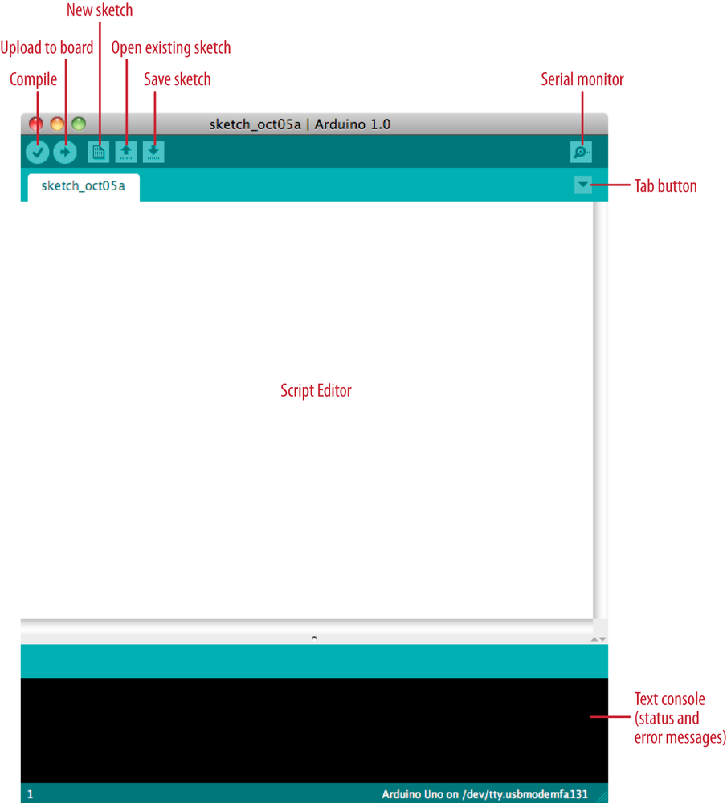

Fig. 4.1 Parts of Arduino IDE

* **Compile**: Before program “code” can be sent to the board, it needs to be converted into instructions that the board understands. This process is called Compiling.
* **Stop**: This stops the compilation process.
* **Create new Sketch**: This opens a new window to create news ketch.
* **Open Existing Sketch**: This loads a sketch from a file on our computer.
* **Save Sketch**: This saves the changes to the sketch.
* **Upload to** Board: This compiles and then transmits over the USB cable to our board.
* **Serial Monitor**: Until this point when our programs (sketches) didn’t work, we just pulled out our hair and tried harder.
* **Tab Button**: This lets you create multiple files in your sketch. This is for more advanced programming than we will do in this class.
* **Sketch Editor**: This is where write or edit sketches
* **Text Console**: This shows you what the IDE is currently doing and is also where error messages display if make a mistake in typing program.
* **Line Number**: This shows what line number your cursor is on.

**ThingSpeak**

ThingSpeak is an [open source](https://en.wikipedia.org/wiki/Open_source) [Internet of Things](https://en.wikipedia.org/wiki/Internet_of_Things) (IoT) application and [API](https://en.wikipedia.org/wiki/API) to store and retrieve data from things using the [HTTP](https://en.wikipedia.org/wiki/HTTP) protocol over the Internet or via a Local Area Network. ThingSpeak enables the creation of sensor logging applications, location tracking applications, and a social network of things with status updates.

In thingspeak a channel is created and the sensor data from the arduino is sent to this channel using the write api key of the channel and the values are read to the website using the read api key of that particular channel.

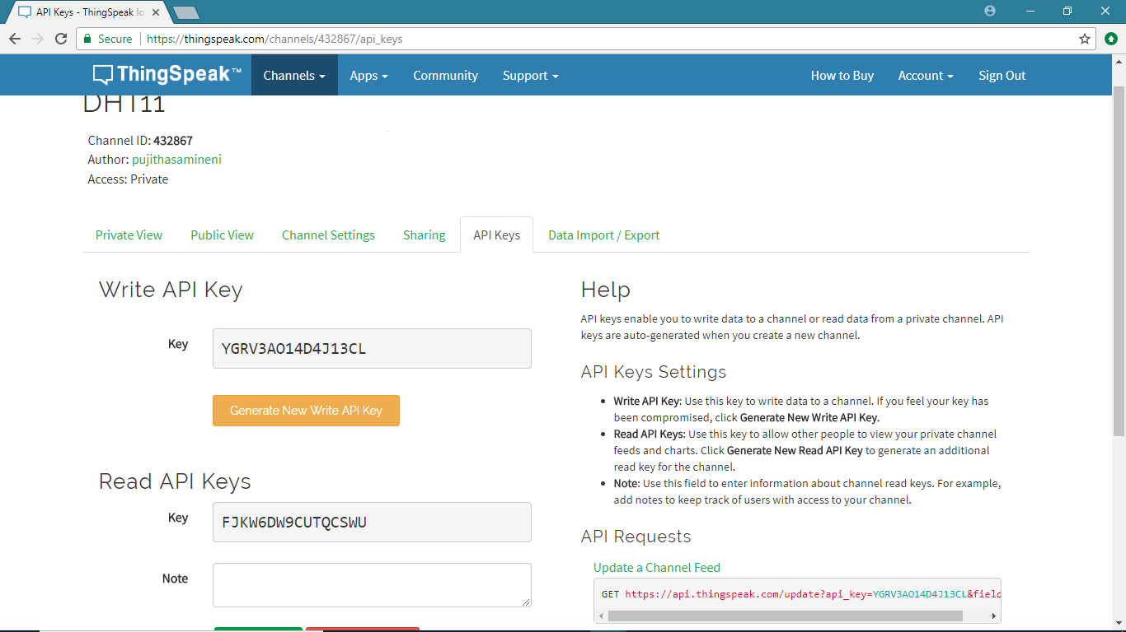

**Write API Key**

**Read API Key**

Fig. 4.2 ThingSpeak channel showing write and read api keys

**jQuery**

jQuery is a lightweight, “write less, do more”, JavaScript library. The purpose of jQuery is to make it much easier to use JavaScript on your website. jQuery takes a lot of common tasks that require many lines of JavaScript code to accomplish, and wraps them into methods that you can call with a single line of code. jQuery also simplifies a lot of the complicated things from JavaScript, like AJAX calls and DOM manipulation.

The jQuery library contains the following features:

* HTML/DOM manipulation
* CSS manipulation
* HTML event methods
* AJAX

**PHP**

PHP is an acronym for “PHP: Hypertext Preprocessor”. PHP is a widely-used, open source scripting language. PHP scripts are executed on the server.PHP files can contain text, HTML, CSS, JavaScript, and PHP code. PHP can generate dynamic page content. PHP runs on various platforms (Windows, Linux, Unix, Mac OS X, etc.)

**XAMPP**

XAMPP is a [free and open source](https://en.wikipedia.org/wiki/Free_software) [cross-platform](https://en.wikipedia.org/wiki/Cross-platform) [web server](https://en.wikipedia.org/wiki/Web_server) [solution stack](https://en.wikipedia.org/wiki/Solution_stack) package developed by Apache Friends, consisting mainly of the [Apache HTTP Server](https://en.wikipedia.org/wiki/Apache_HTTP_Server), [MariaDB](https://en.wikipedia.org/wiki/MariaDB" \o "MariaDB) [database](https://en.wikipedia.org/wiki/Database), and [interpreters](https://en.wikipedia.org/wiki/Interpreter_(computing)) for scripts written in the [PHP](https://en.wikipedia.org/wiki/PHP) . XAMPP stands for Cross-Platform (X), Apache (A), MariaDB (M), PHP (P) and Perl (P). It is a simple, lightweight Apache distribution that makes it extremely easy for developers to create a local web server for testing and deployment purposes. Everything needed to set up a web server – server application (Apache), database (MariaDB), and scripting language (PHP) – is included in an extractable file. XAMPP is also cross -platform, which means it works equally well on Linux, Mac and Windows. Since most actual web server deployments use the same components as XAMPP, it makes transitioning from a local test server to a live server extremely easy as well.

**CODE IGNITER**

CodeIgniter is a toolkit for people who build web applications using PHP. Its goal is to enable you to develop projects much faster than you could if you were writing code from scratch, by providing a rich set of libraries for commonly needed tasks, as well as a simple interface and logical structure to access these libraries. CodeIgniter lets you creatively focus on your project by minimizing the amount of code needed for a given task.

CodeIgniter is Light Weight

Truly light weight. The core system requires only a few very small libraries. This is in stark contrast to many frameworks that require significantly more resources. Additional libraries are loaded dynamically upon request, based on your needs for a given process, so the base system is very lean and quite fast.

CodeIgniter is Fast: Really fast. We challenge you to find a framework that has better performance than CodeIgniter.

CodeIgniter Uses M-V-C

CodeIgniter uses the Model-View-Controller approach, which allows great separation between logic and presentation. This is particularly good for projects in which designers are working with your template files, as the code these files contain will be minimized. We describe MVC in more detail on its own page.

**4.2. UML Diagrams**

System Design also called top-level design aims to identify the modules that should be in the system, the specifications of these modules, and how they interact with each other to produce the desired results. At the end of the system design all the major data structures, file formats, output formats, and the major modules in the system and their specifications are decided.

UML diagrams are the ultimate output of the entire discussion. All the elements, relationships are used to make a complete UML diagram and diagram represents a system. The visual effect of the UML diagram is the most important part the entire process. All the either elements are used to make it a complete one.

There are two broad categories of diagrams and they are again divided into subcategories – Structural Diagrams, Behavioral Diagrams.UML includes the following nine diagrams as follows.

* Class diagrams
* Object diagram
* Use case diagram
* Sequence diagram
* Collaboration diagram
* Activity diagram
* State chart diagram
* Deployment diagram
* Component diagram

Class diagram, Object diagram, Component diagram, Deployment diagram come under Structural diagrams where as Use-case diagram, Sequence diagram, Collaboration diagram, Statechart diagram, Activity diagram comes under Behavioural diagrams

### **4.2.1 State chart Diagram**

A state chart diagram shows the behavior of classes in response to external stimuli. This diagram models the dynamic flow of control from state to state within a system.

The state diagram below depicts the flow of the project. Once the connections of the circuit is completed the USB is connected to the system to dump the code into Arduino. After the code is dumped, sensors collect the data and display them on the serial monitor then a wifi module is used to send the data from the Arduino to Thingspeak. Sensor data and farmers loan history is retrieved and then analysis is performed on this data for suggesting the banks for waiving or granting the loans and for knowing the farm condition during repayment.

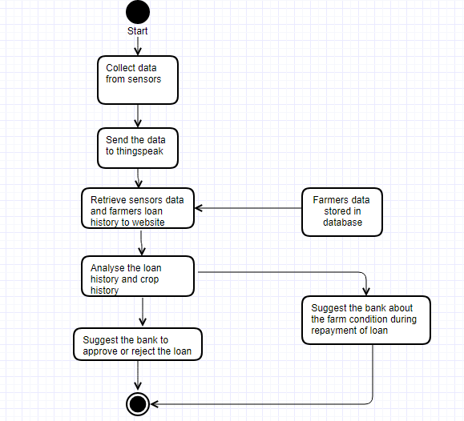

Fig. 4.3 State Diagram for flow of the project

### **4.2.2 Use Case Diagram**

The use case diagram depicts the Web application which is used by both farmers and loan lenders (banks). The Website consists of Home, About, Services, Farmer Login, Bank Login and Contact us Pages.

User of the Web application can either be a farmer or a bank admin

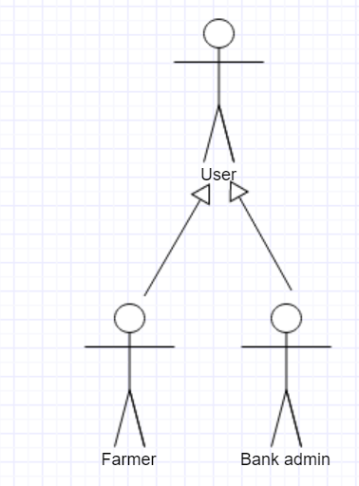

Fig. 4.4 Usecase diagram for User

Farmer can access to home, about, services, farmer login and contact us pages

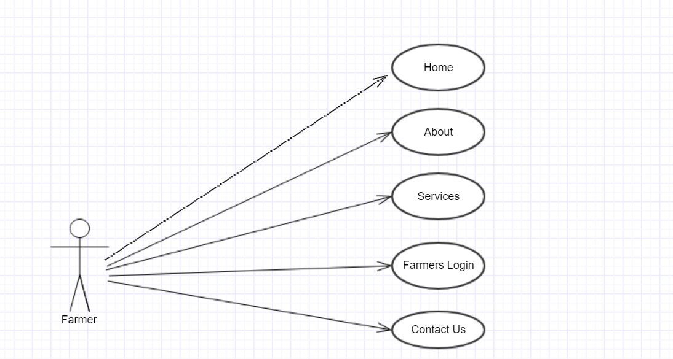

Fig. 4.5 Usecase diagram of Web Application for Farmer

Bank Admin can access to home, about, services, bank login and contact us pages

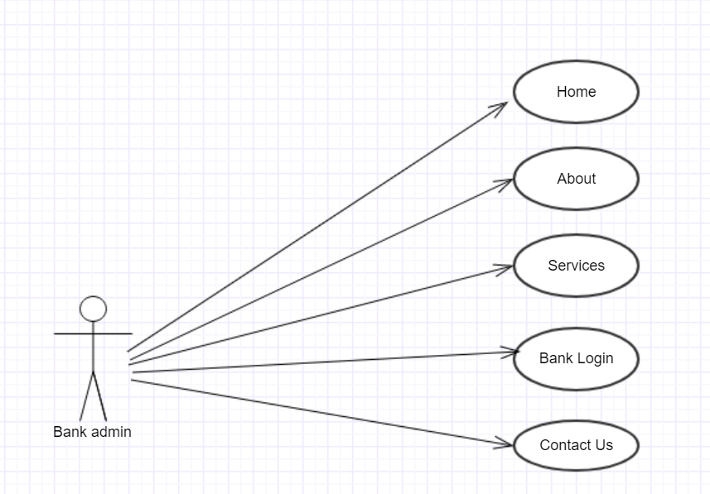

Fig. 4.6 Usecase diagram of Web Application for Bank Admin

The usecase diagram depicts the options provided for the farmer. A farmer can login to his account using the Aaadhaar card number and password which is validated with the data present in the database . A sign up option is also provided if he/she doesnot have an account. After the farmer log in he/she can make a loan request to the bank .Once he/she clicks on the loan request button a loan application is added to the list of loan applications of that particular farmer.

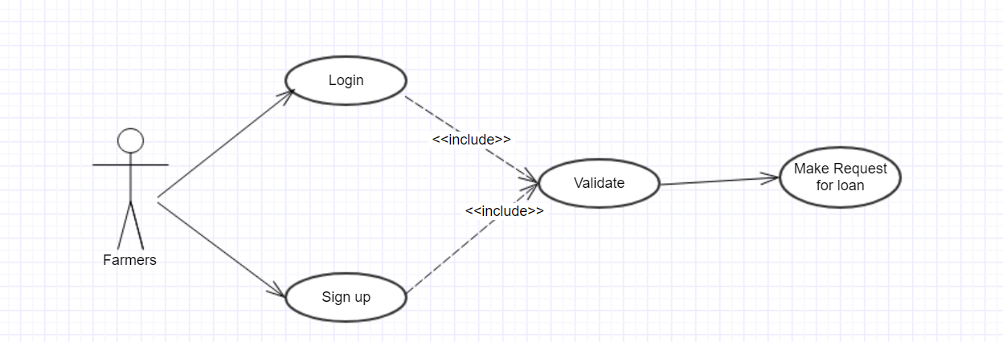

Fig. 4.7 Usecase diagram of farmer’s view

Bank Admin can login and see all the loan applications. All the applications of single farmer can also be viewed. He/she can approve or reject the loan based on the suggestion. Repayment option is also provided once the admin goes to repayment page he needs to search for the particular farmer using the Aaadhaar card number, all the application of the farmer along with the farm condition and status are shown by which he can question the farmer regarding the repayment of the loan.

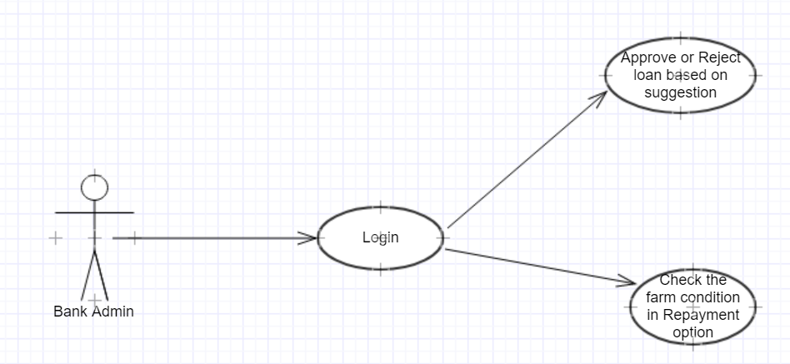

Fig. 4.8 Usecase diagram of banker’s view

### **4.2.3. Sequence Diagram**

When a farmer or bank admin logs in he/she is validated with the data present in the database. Farmer makes a loan request to the bank and banks approve or reject the loan based on suggestion, this suggestion is given by analyzing the sensor data and the loan history of that particular farmer. If a farmer comes for the repayment then the bank admin checks the farm condition and question back the farmer accordingly.

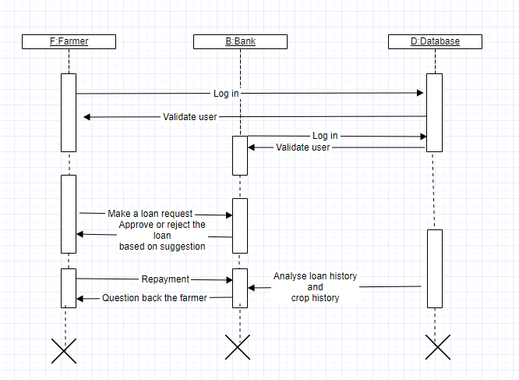

Fig. 4.9 Sequence diagram of Web Application

# 5. RESULTS

Output of the arduino sending data to thingspeak on the serial monitor



Fig.5.1 Serial Monitor Output

Showing result in the thingspeak cloud after the data has been sent to thingspeak from arduino. Graphs of temperature, humidity and soil moisture are shown below.

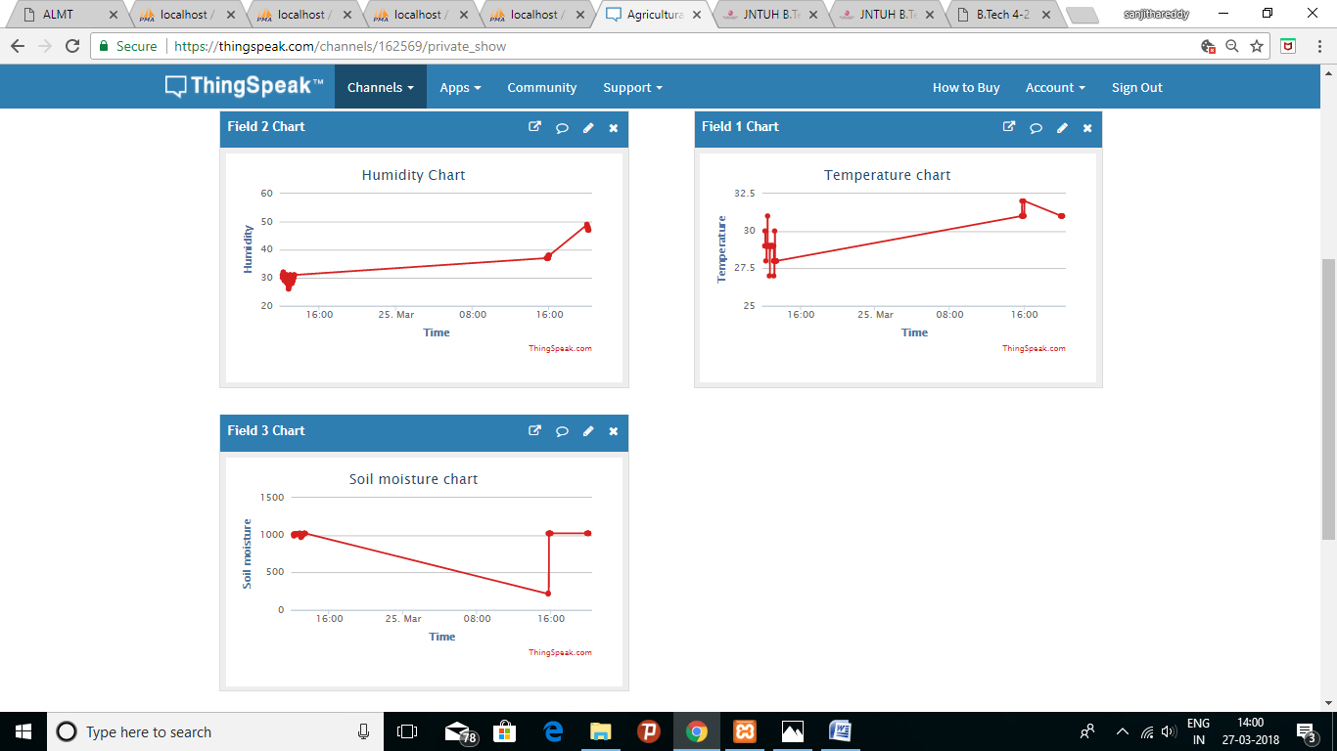

Fig.5.2 Thingspeak Output

Home page of the web application is as follows:

It includes a menu with About, Services, Farmer login, Bank login, Contact us options for user accessibility.

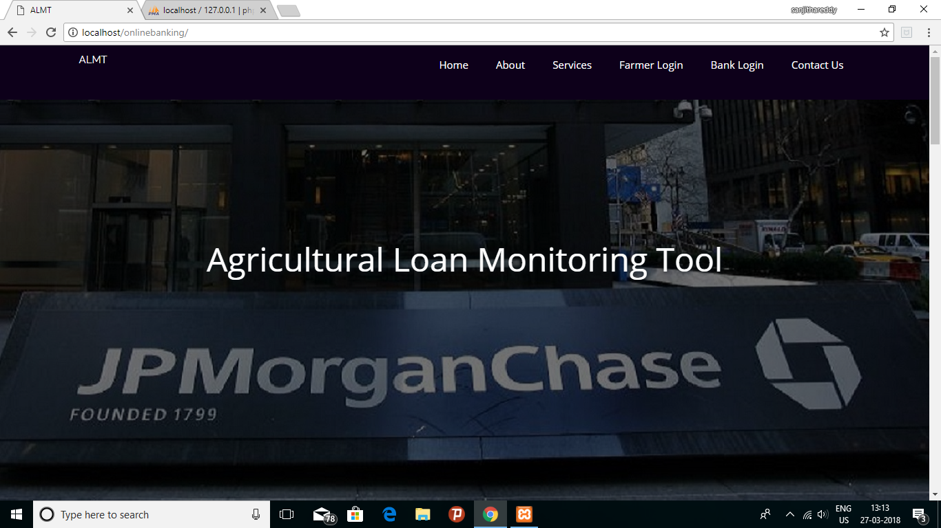

Fig.5.3 Home Page of Web Application

About – It gives brief description about the company and its activities.

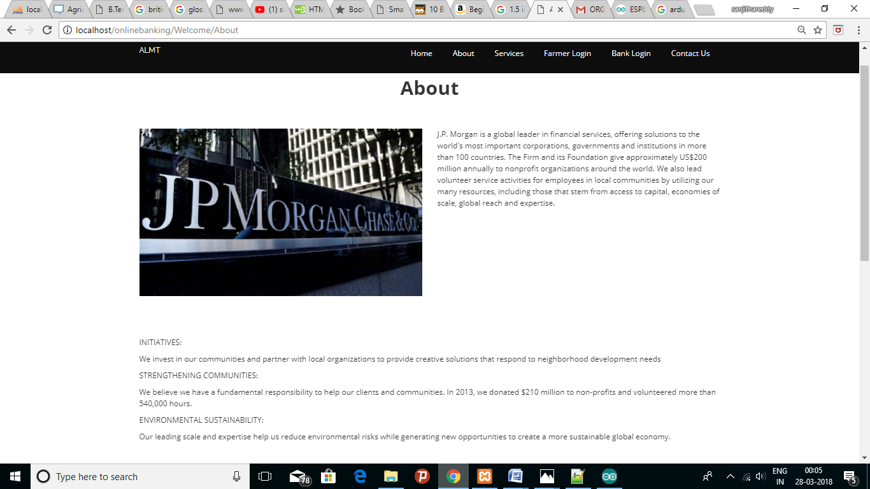

Fig.5.4 About Us Page

Services – It describes the services provided by JPMorgan Chase & Co.

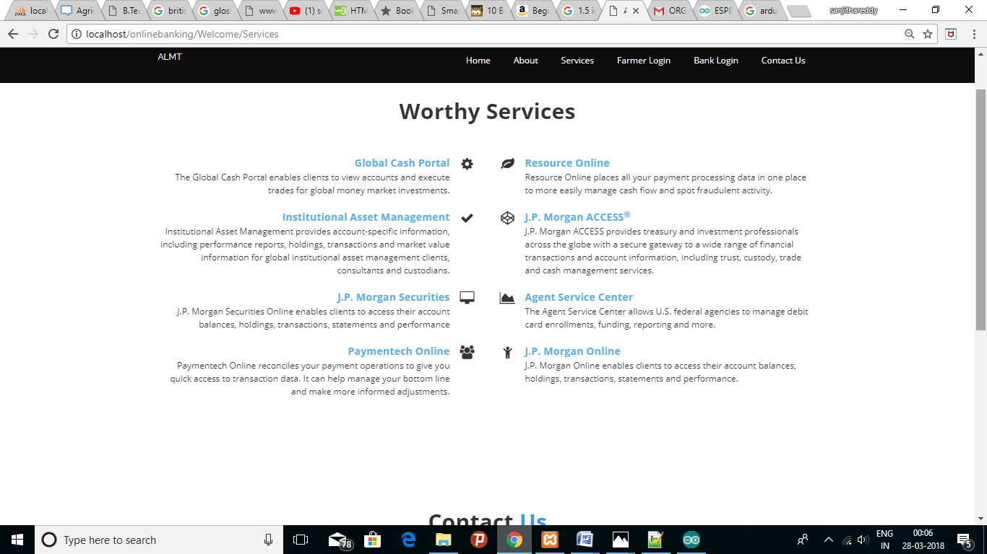

Fig 5.5 Services Page

Contact Us – It includes the basic contact information.

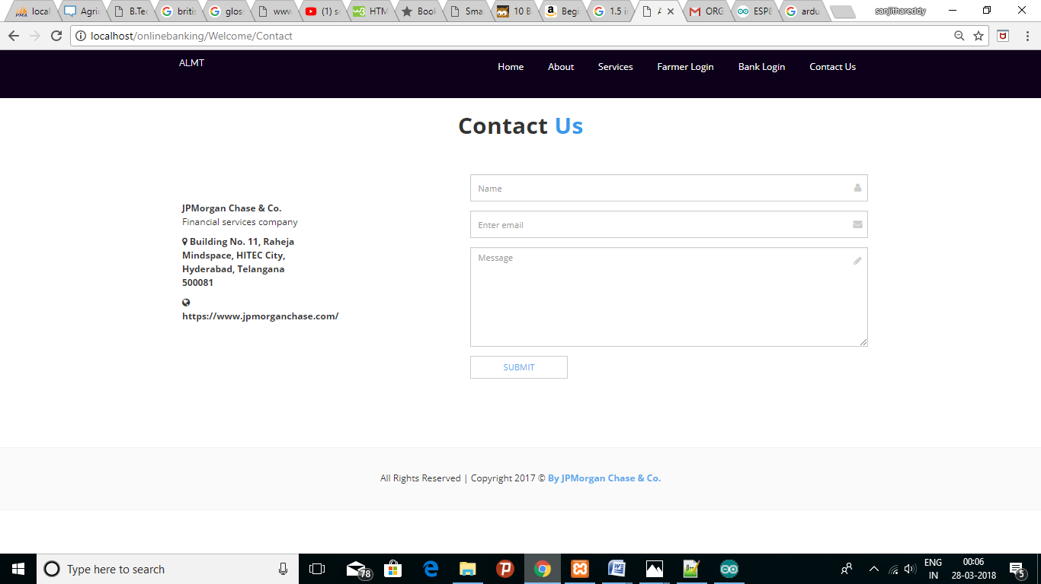

Fig.5.6 Contact Us Page

Farmer’s login page:

If user does not have an account he/she need to sign up by clicking on “create a new account” else user can login by using his credentials.

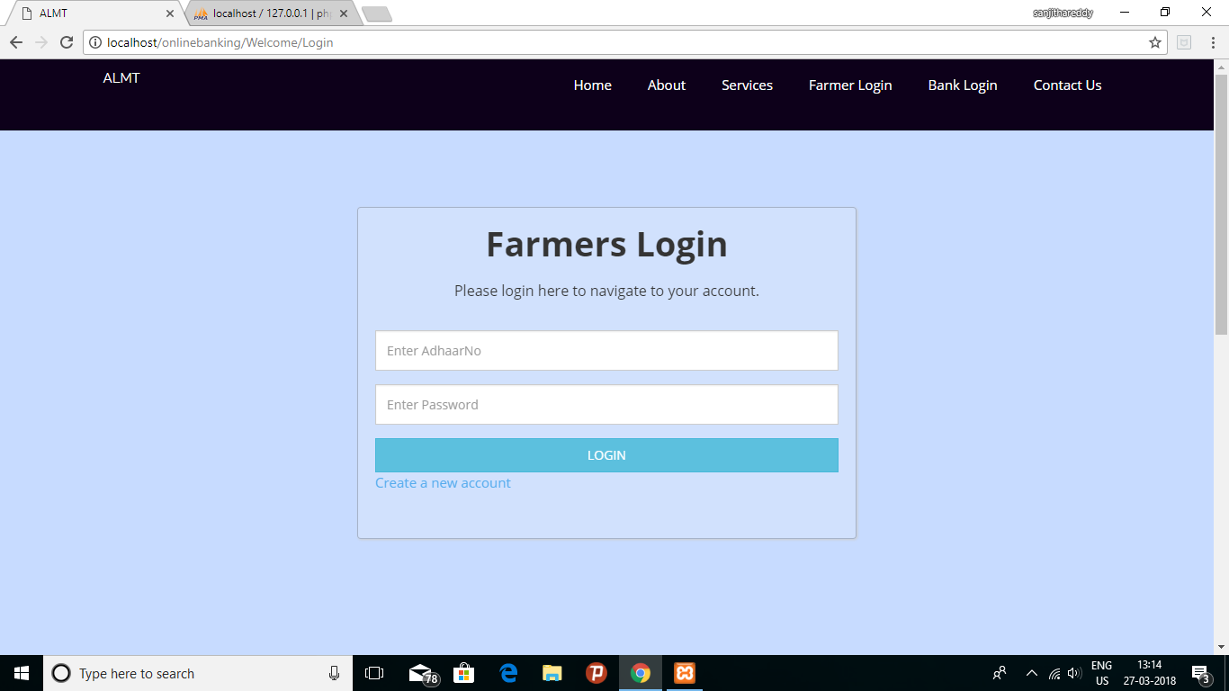

Fig 5.7 Farmers Login Page

Farmer’s signup page:

To create a new account for accessing the services the user needs to enter the following details.

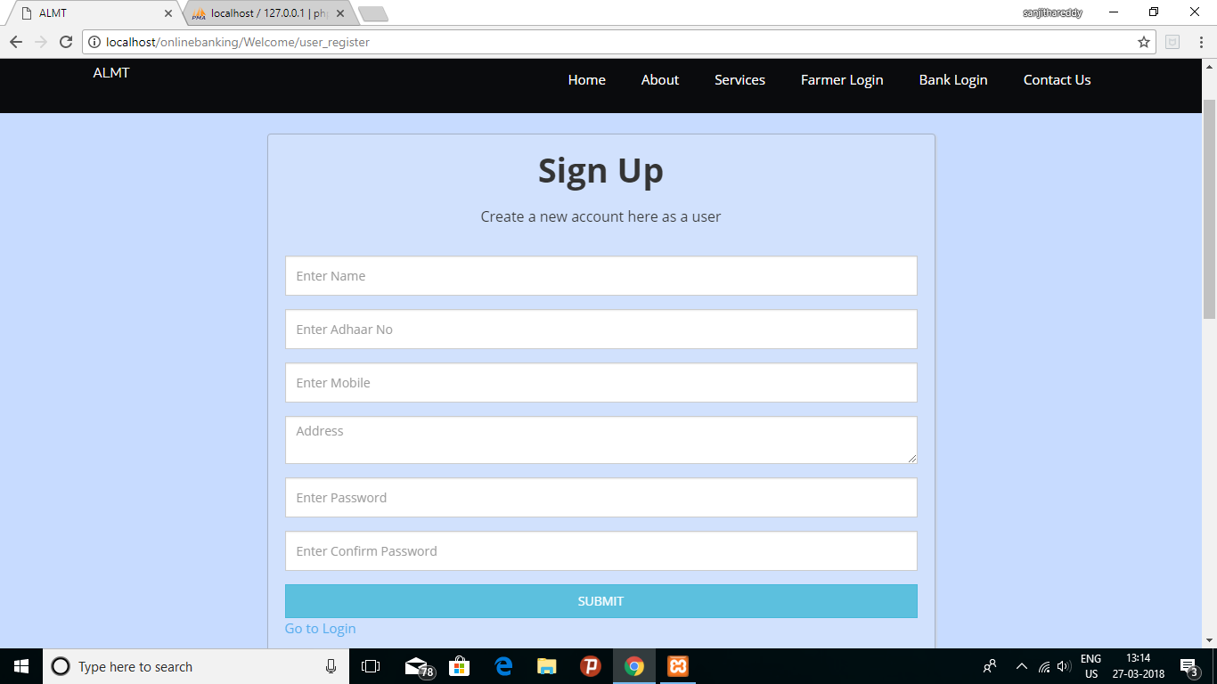

Fig.5.8 Farmers’s Sign up page

When the user successfully logs in, “My account” page of the particular farmer gets displayed.

It includes Account details, applied loan records of the farmer and it also contains “Make a request for a new loan” option.

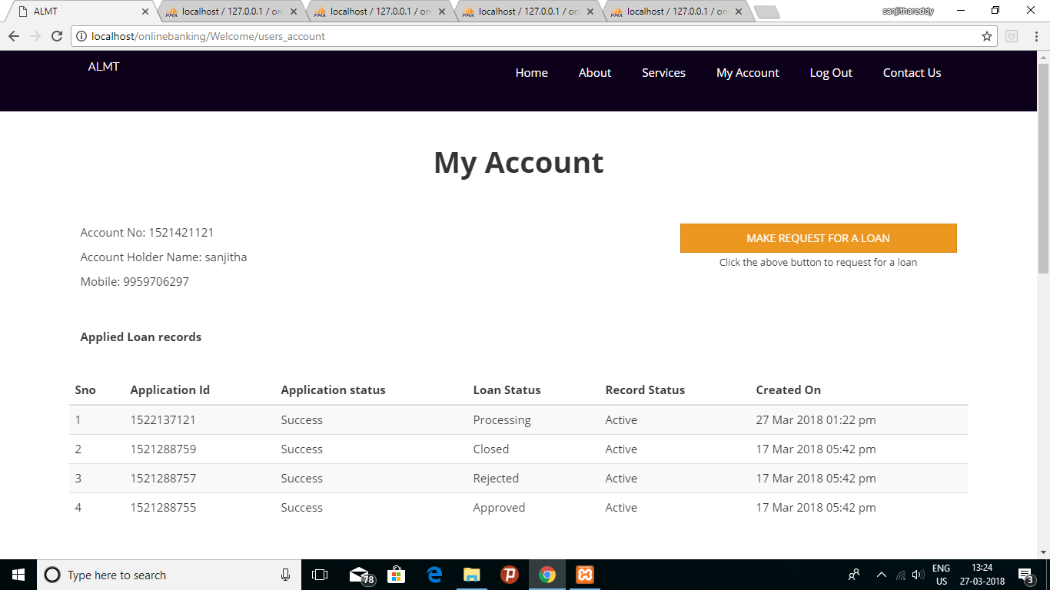

Fig.5. My Account Page of Farmer

Bank admin’s login page:

Bank admin/ Loan lender can access the services by entering the credentials.

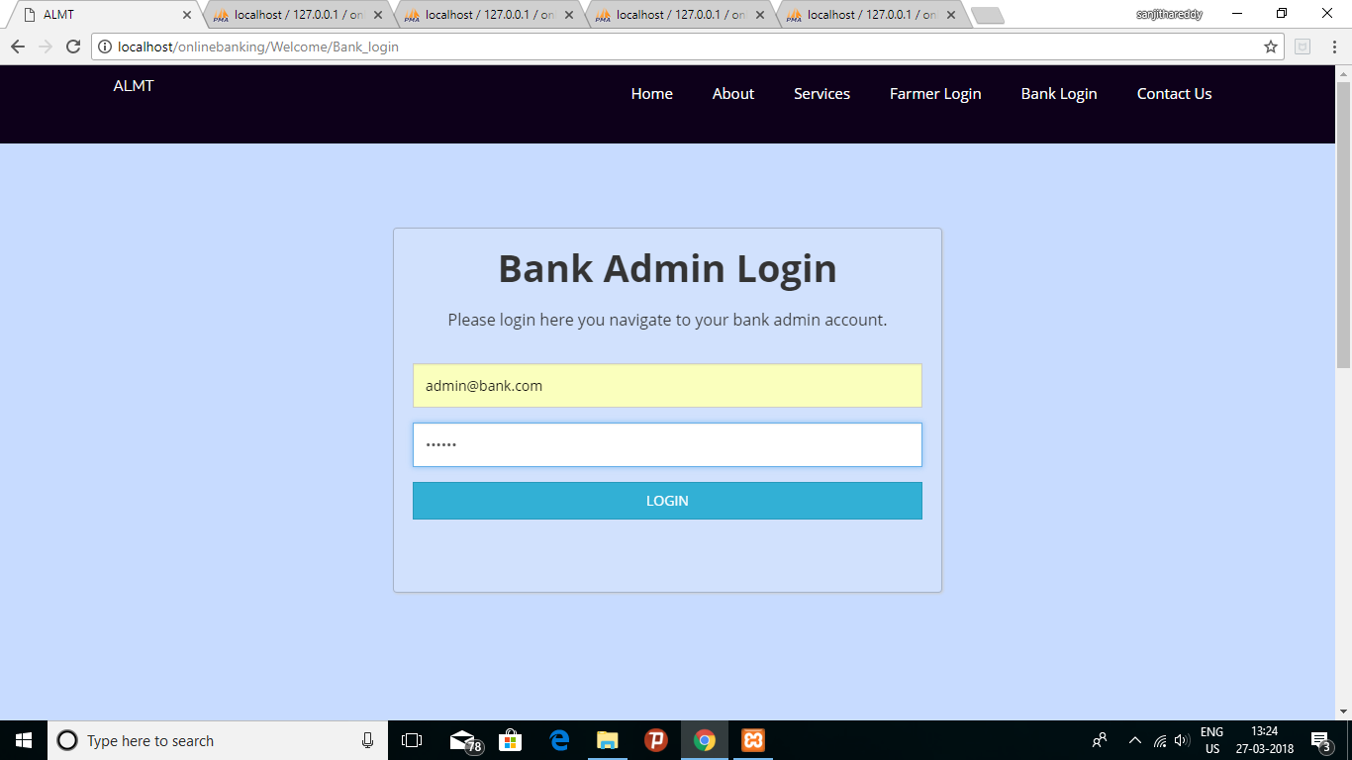

Fig.5.10 Bank Admin Login Page

Bank admin account page:

It displays all the loan applications by farmers.

Loan applications of particular farmer can be viewed by entering the aadhaar number or account number in the search box.

Every loan application contains a suggestion and accordingly action can be taken by the admin to either approve or reject it.

Re-payment option redirects the bank admin to its respective page.

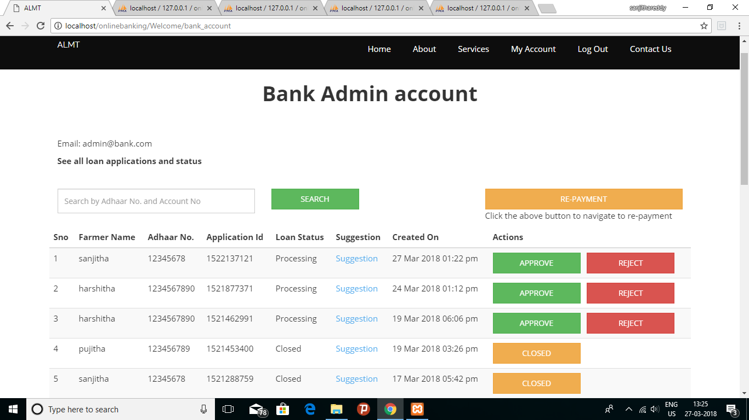

Fig.5.11 Bank Admin Account Page with all the loan applications

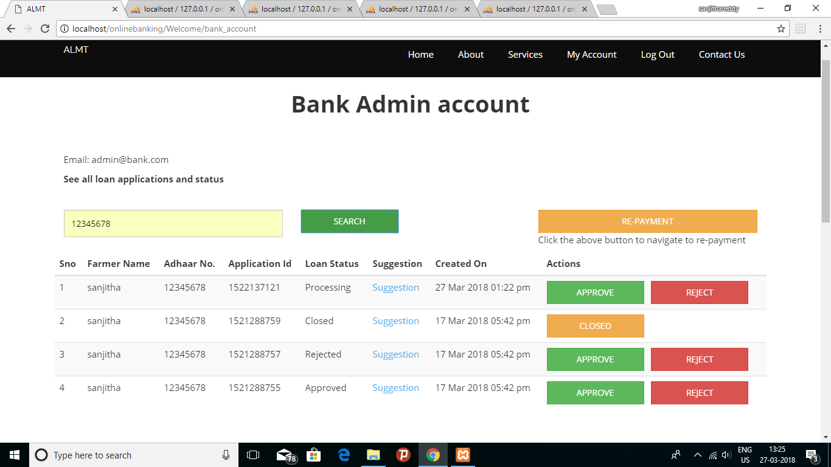

Fig.5.12 Bank Admin Account Page with all the loan applications of particular farmer

Suggestion to whether approve or reject the loan for each farmer is displayed based on the loan and crop history.

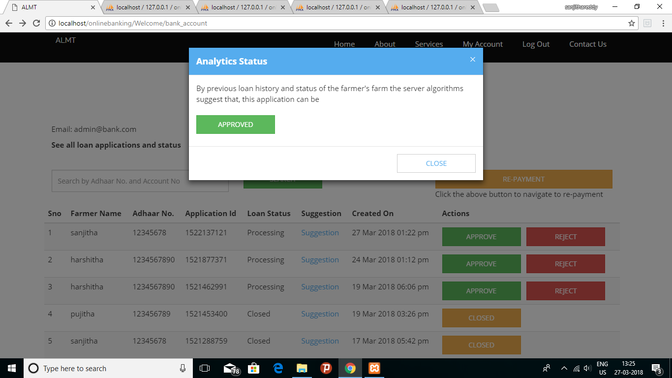

Fig.5.13 Suggestion about loan approval

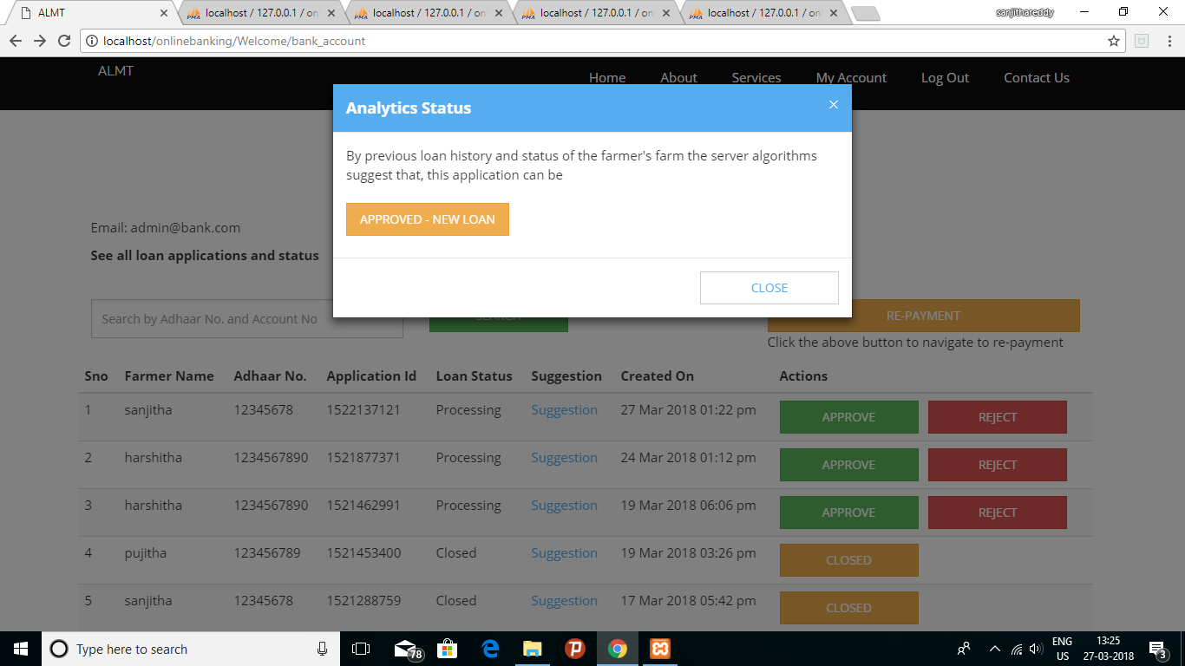

Fig.5.14 Suggestion about new loan approval

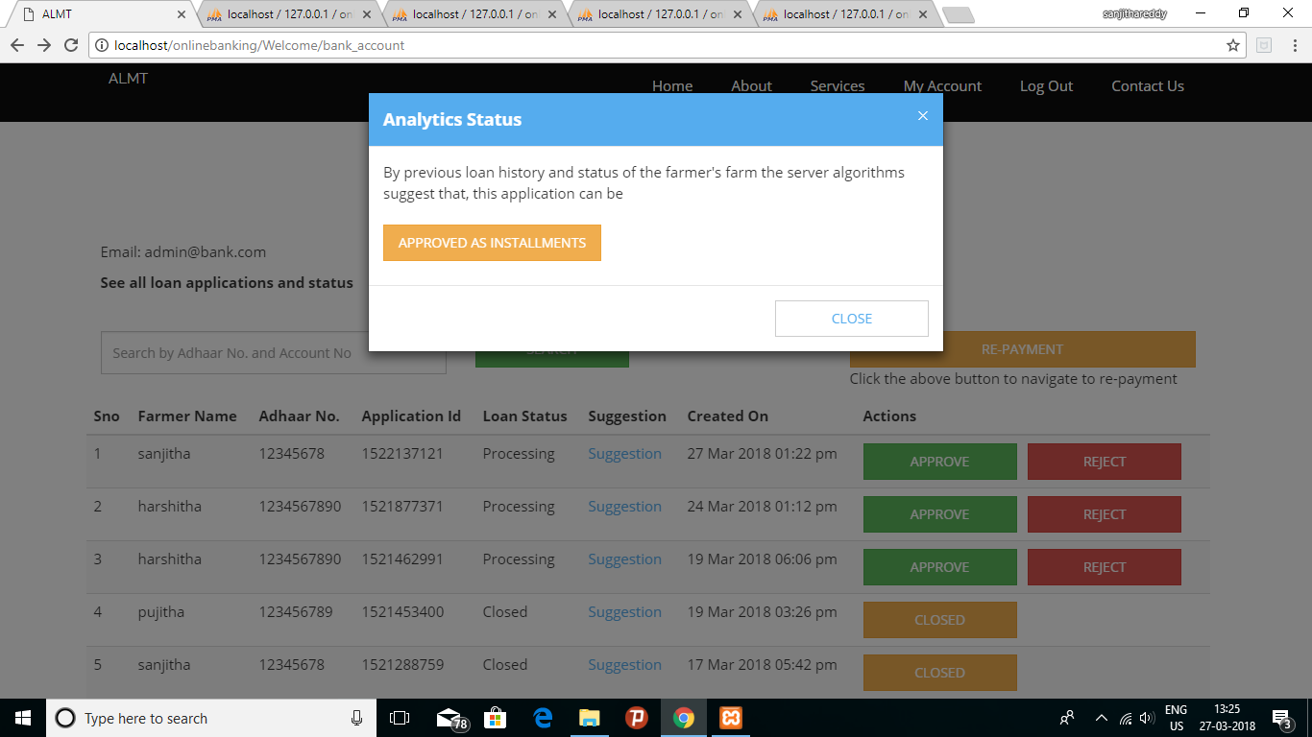

Fig.5.15 Suggestion about loan approval in installments

Re-payment module:

Bank admin can access each farmer’s loan details by using the aadhaar number,

Farm condition of the applicant is displayed at the bottom of the page.

Once the repayment is done loan application is closed.

Before searching the farmer details:

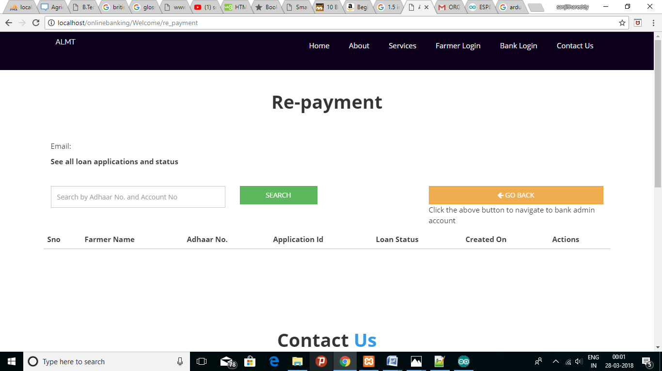

Fig.5.16 Repayment Page

After searching the farmer details:

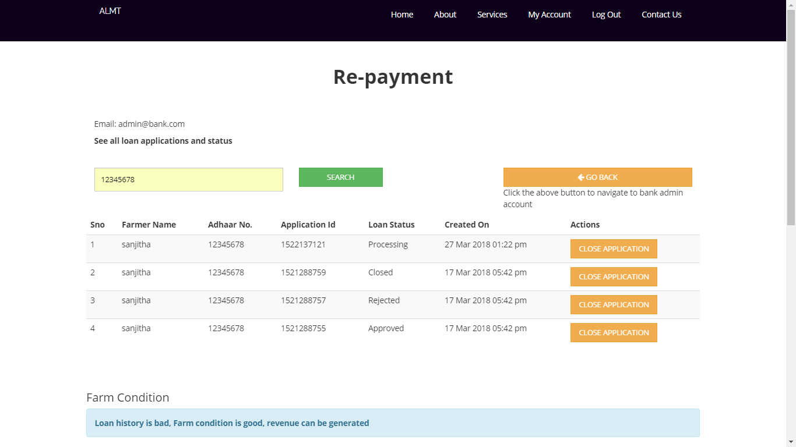

Fig. 5.17 Farm condition of a particular farmer

After closing the application:

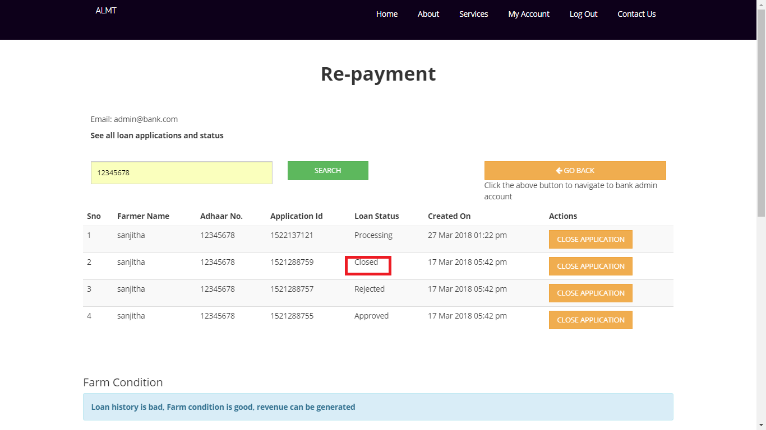

Fig. 5.18 Closing of the loan application

Farmer account details, loan details and bank credentials are stored in the Database.

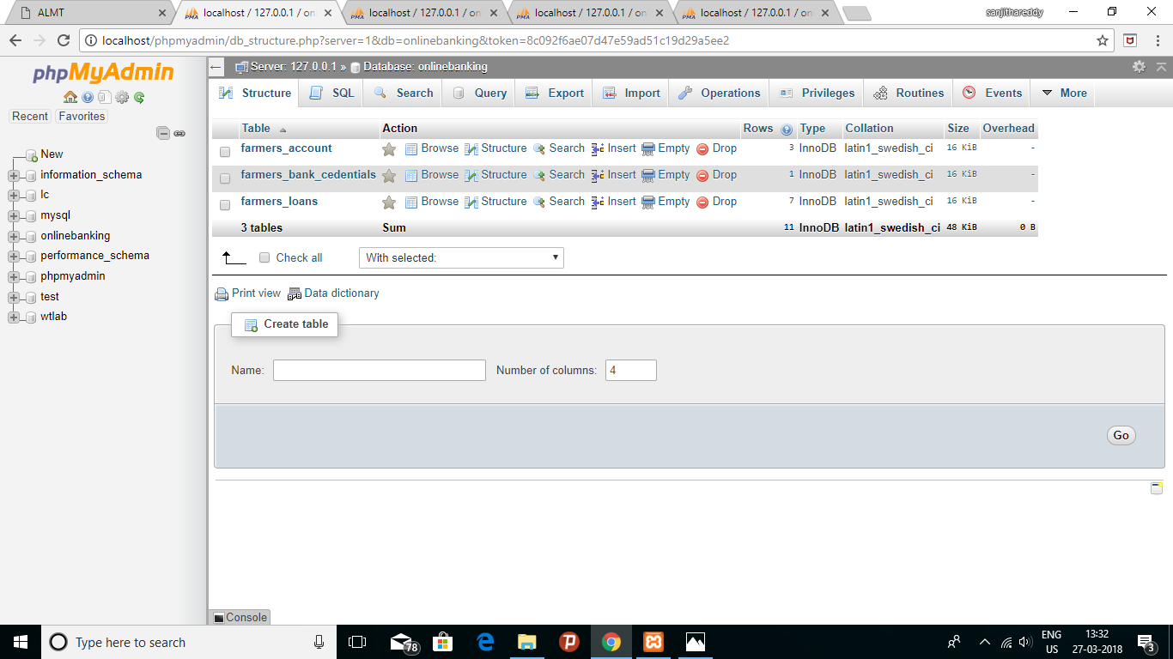

Fig. 5.19 Database details

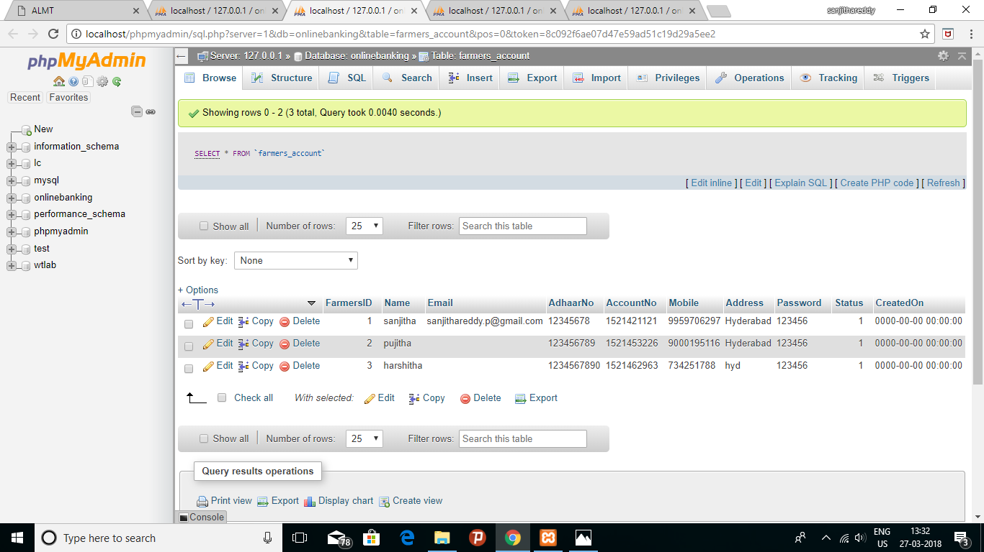

Fig.5.20 Farmer Account details

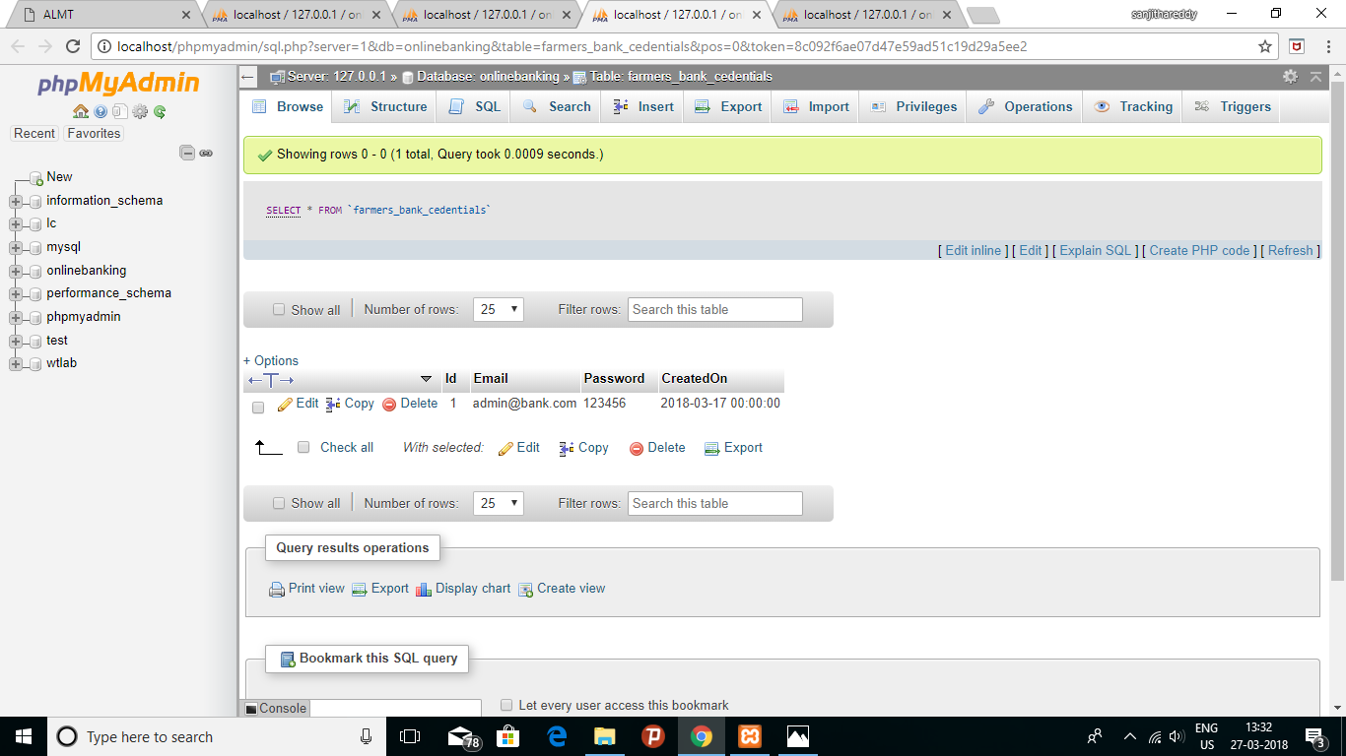

Fig. 5.21 Bank Admin Credentials

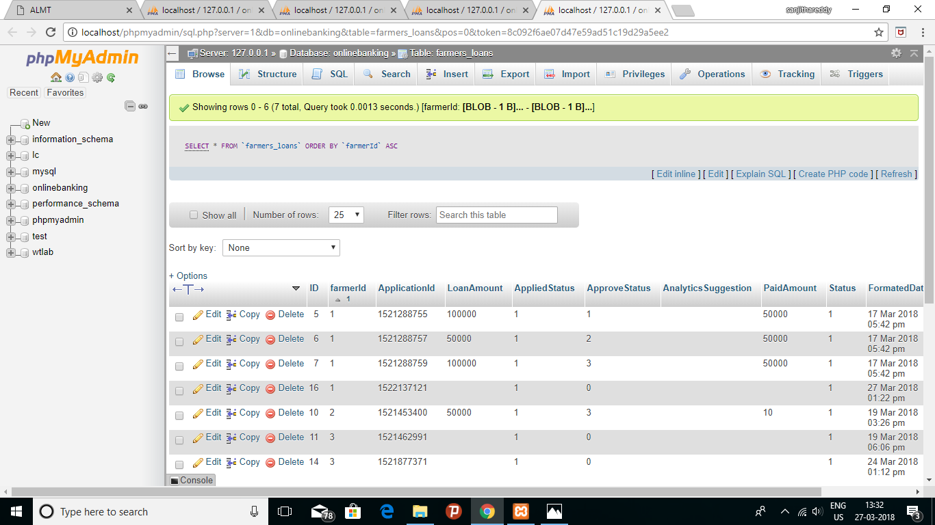

Fig. 5.22 Farmer Loan details

# 6. CONCLUSIONS AND SCOPE FOR FUTURE ENHANCEMENTS

## 6.1. Conclusions

The Agricultural Loan Monitoring tool allows us to monitor climatic conditions for agricultural land and suggest the Bank to Assess, Waive or Grant new Agricultural loans . This tool allows banks to test the trustworthiness of the farmers. It also helps us to ensure that the loan is repayed properly without any false excuses.

Many loaning organizations and farmers can use this tool for better judgement and loan monitoring.

## 6.2. Future Enhancements

The project can be further improved with following enhancements

1. The crop analysis can be further improved as different analysis procedure for different crops in different seasons respectively.

2. Different thingspeak channels must be used for different farmers to take the crop analysis for every farmer in particular and a database must be maintained for every farmers thingspeak details i.e, mapping of farmer’s field with a particular thingspeak channel.

3. Loan details of every farmer must be taken dynamically and stored in the database.

4. The algorithm used for suggesting the loan lenders whether to approve the loan or not can be further improved with detailed and precise loan and crop analysis.

## REFERENCES

**List of Text Books:**

1. [Charalampos Doukas](https://www.google.co.in/search?tbo=p&tbm=bks&q=inauthor:%22Charalampos+Doukas%22), Building Internet of Things with the Arduino, Volume 1, CreateSpace Independent Publishing Platform, 2012.

2. [Charles Bell](https://www.amazon.com/s/ref=dp_byline_sr_book_1?ie=UTF8&text=Charles+Bell&search-alias=books&field-author=Charles+Bell&sort=relevancerank)Beginning Sensor Networks with Arduino and Raspberry Pi, 1st edition, Apress, 2013

3. [Marco Schwartz](https://www.amazon.com/Marco-Schwartz/e/B00KBZDUCY/ref=dp_byline_cont_book_1) , Internet of Things with ESP8266, 1st Edition, Packt Publishing , 2016

4. [Matthijs Kooijman](https://www.amazon.com/s/ref=dp_byline_sr_book_1?ie=UTF8&text=Matthijs+Kooijman&search-alias=books&field-author=Matthijs+Kooijman&sort=relevancerank), Building Wireless Sensor Networks Using Arduino, 1st edition, Packt Publishing, 2015.

5. [Charles Bell](https://www.amazon.com/s/ref=dp_byline_sr_book_1?ie=UTF8&text=Charles+Bell&search-alias=books&field-author=Charles+Bell&sort=relevancerank)Beginning Sensor Networks with Arduino and Raspberry Pi, 1st edition, Apress, 2013

6. [Michael Margolis](https://www.amazon.com/s/ref=dp_byline_sr_book_1?ie=UTF8&text=Michael+Margolis&search-alias=books&field-author=Michael+Margolis&sort=relevancerank), Arduino Cookbook, 2nd Edition, O'Reilly Media, 2011

7. Riwanto Megosinarso, Step By Step Bootstrap 3: A Quick Guide to Responsive Web Development Using Bootstrap 3, 1 edition, CreateSpace Independent Publishing Platform,2014

**List of Journal Papers and Conference Papers:**

1. [B. Balaji Bhanu](http://ieeexplore.ieee.org/search/searchresult.jsp?searchWithin=%22Authors%22:.QT.B.%20Balaji%20Bhanu.QT.&newsearch=true),  [K. Raghava Rao](http://ieeexplore.ieee.org/search/searchresult.jsp?searchWithin=%22Authors%22:.QT.K.%20Raghava%20Rao.QT.&newsearch=true),  [J.V.N. Ramesh](http://ieeexplore.ieee.org/search/searchresult.jsp?searchWithin=%22Authors%22:.QT.J.V.N.%20Ramesh.QT.&newsearch=true), Agriculture field monitoring and analysis using wireless sensor networks for improving crop production

[2014 Eleventh International Conference on](http://ieeexplore.ieee.org/xpl/mostRecentIssue.jsp?punumber=6912065) [Wireless and Optical Communications Networks (WOCN)](http://ieeexplore.ieee.org/xpl/mostRecentIssue.jsp?punumber=6912065), Sept. 2014

2. D.K. Sreekantha, Kavya A.M., "Agricultural crop monitoring using IOT - a study",11th International Conference on Intelligent Systems and Control (ISCO) 2017 pp. 134-139, 2017.

3. Sonal Varma, Nikhil Chug, Dhananjay V. Gadre, Wireless Sensor Network for Crop Field Monitoring, [2010 International Conference on](http://ieeexplore.ieee.org/xpl/mostRecentIssue.jsp?punumber=5459230) Recent Trends in Information, Telecommunication and Computing (ITC), 2010.

4. Supriya C. Padwal, Manoj Kumar, P. Balaramudu, Chanakya Kumar Jha, "Analysis of environment changes using WSN for IOT applications", Convergence in Technology (I2CT) 2017 2nd International Conference for, pp. 27-32, 2017.

5. O. Pandithurai, S. Aishwarya, B. Aparna, K. Kavitha, "Agro-tech: A digital model for monitoring soil and crops using internet of things (IOT)", Science Technology Engineering & Management (ICONSTEM) 2017 Third International Conference on*,* pp. 342-346, 2017.

6. Mihai T. Lazarescu, "Design of a WSN Platform for Long-Term Environmental Monitoring for IoT Applications*",*Emerging and Selected Topics in Circuits and Systems IEEE Journal on*,* vol. 3, pp. 45-54, 2013, ISSN 2156-3357.

7. Norvald INSTEFJORD, NAKATA Hiroyuki, Loan Monitoring and Bank Risk, RIETI Discussion Paper Series 15-E-121, October 2015

**Websites:**

1. <https://community.thingspeak.com/tutorials/>

2. <https://community.thingspeak.com/tutorials/arduino/send-data-to-thingspeak-with-arduino/>

3. <https://thingspeak.com/pages/how_to>

4. <https://in.mathworks.com/help/thingspeak/getting-started-with-thingspeak.html?requestedDomain=true>

5. <https://circuitdigest.com/microcontroller-projects/sending-arduino-data-to-webpage>

6. <http://www.instructables.com/id/PART-1-Send-Arduino-data-to-the-Web-PHP-MySQL-D3js/>

7. <https://github.com/mathworks/thingspeak-arduino>

8. <https://github.com/esp8266/Arduino/tree/master/libraries>

9. <https://www.youtube.com/watch?v=sPfJ9f1FuUE>

10. <https://www.youtube.com/watch?v=GpiWeFa3D7c>

11. <https://www.youtube.com/watch?v=qU76yWHeQuw>

12. <https://www.youtube.com/watch?v=ETLDW22zoMA>

13. <https://www.geekstips.com/esp8266-arduino-tutorial-iot-code-example/>

14. <https://www.espressif.com/sites/default/files/documentation/4a-esp8266_at_instruction_set_en.pdf>

15. <http://www.instructables.com/id/Get-Started-With-ESP8266-Using-AT-Commands-Via-Ard/>

16. <https://www.tutorialspoint.com/codeigniter/index.htm>

17. <https://www.codeigniter.com/userguide3/tutorial/index.html>

18. <https://www.javatpoint.com/codeigniter-tutorial>

19. <http://tutorialcodeigniter.com/>

20. <https://www.w3schools.com/bootstrap/default.asp>

21. <https://www.tutorialspoint.com/bootstrap/index.htm>

22. <https://www.w3schools.com/jquery/default.asp>

23. <https://www.w3schools.com/js/js_json_intro.asp>

24. <https://www.w3schools.com/colors/colors_picker.asp>

## GLOSSARY

**A**

**A/D Converter :** an analog-to-digital converter (ADC, A/D, or A to D) is a device that converts a continuous physical quantity (usually voltage) to a digital number that represents the quantity's amplitude.

**API :** a set of functions and procedures that allow the creation of applications which access the features or data of an operating system, application, or other service.

**AVR:** It is a family of microcontrollers developed by atmel.

**AT:** Attention command set. They are a set of commands that are sent to a cellular module to perform different actions

**C**

**COM:** Common connection for relay or transistor outputs

**CSS:** Cascading Style sheet. This programming language is used to apply styles for HTML pages

**D**

**DHT:** Digital Humidity and Temperature Sensor. It detects the temperature and the humidity

**E**

**ESP8266:** It is aWiFi Module with self contained SOC with integrated TCP/IP protocol stack that can give any microcontroller access to your WiFi network

**G**

**Gnd:** Ground, It is reference point in electrical circuit from which voltages are measured

**GPIO’S:** General purpose Input Output. It is generic pin on an integrated circuit.

**H**

**HTTP:** HyperText Transfer Protocol. It is an application protocol used for data communication

**HTML:** HyperText Markup Language. It is used for creating Webpages.

**I**

**IDE :** An integrated development environment (IDE) is a programming environment that has been packaged as an application program, typically consisting of a code editor, a compiler, a debugger, and a graphical user interface (GUI) builder.

**IoT:** Internet of Things. It deals with sensor networks

**IP:** Internet Protocol. It is a communication protocol to exchange data.

**J**

**JSON:** JavaScript Object Notation. It is light weight data interchange Format.

**JQUERY:**  jQuery is a lightweight, "write less, do more", JavaScript library.

**K**

**Kernel :** the most basic level or core of an operating system, responsible for resource allocation, file management, and security.

**M**

**Microcontroller :** a control device which incorporates a microprocessor.

**MIPS :** a unit of computing speed equivalent to a million instructions per second.

**MCU:** MicroController Unit. It is a small computer on a single integrated circuit.

**N**

**NTC:** Negative Temperature Coefficient. It means resistance decreases with increasing temperature.

**P**

**PHP:** Hypertext Preprocessor. It is a widely-used, open source scripting language

**R**

**RTC :** Real Time Clock.It is a computer clock that keeps track of the current time.

**RX:** Receiver pin. It receives the input

**S**

**SOC:** System on a Chip. It is micro chip with all the necessary electronic circuits

**SSL**: Secured socket layer. It is a computer networking protocol for secure connections

**T**

**TCP:** Transmission Control Protocol.It is a suite of communication protocols used to interconnect networks.

**TX:** Transmitter pin. It sends the output

**U**

**UART:** Universal Asynchronous Receiver Transmitter. It is usually an individual Integrated Circuit used for serial communication

**UDP:** User Datagram Protocol. It is used for establishing low latency and loss tolerating connections.

**V**

**Vcc:** Voltage, common collector.

**W**

**Workspace :** a memory storage facility for temporary use.

**X:**

**XML:** Extensible Markup Language. It is a document formatting language.

**XAMPP:** It stands for Cross-Platform (X), Apache (A), MariaDB (M), PHP (P) and Perl (P). It is a [free and open source](https://en.wikipedia.org/wiki/Free_software) [cross-platform](https://en.wikipedia.org/wiki/Cross-platform) [web server](https://en.wikipedia.org/wiki/Web_server) [solution stack](https://en.wikipedia.org/wiki/Solution_stack) package developed by Apache

## APPENDIX

**Arduino:**

Arduino is a single-board microcontroller. It is a small computer on a single integrated circuit containing a processor core, memory, and programmable input/output peripherals.

**Arduino IDE:**

Arduino is an open-source electronics prototyping platform based on flexible, easy-to-use hardware and software.

**ThingSpeak:**

Thingspeak is a cloud service that allows you to aggregate, visualize and analyze live data streams in the cloud

**MySQLi:**

The MySQLi Extension ([MySQL](https://en.wikipedia.org/wiki/MySQL" \o "MySQL) Improved) is a [relational database](https://en.wikipedia.org/wiki/Relational_database) driver used in the [PHP](https://en.wikipedia.org/wiki/PHP) [scripting language](https://en.wikipedia.org/wiki/Scripting_language) to provide an interface with [MySQL](https://en.wikipedia.org/wiki/MySQL" \o "MySQL) [databases](https://en.wikipedia.org/wiki/Database).